**LECTURE 1 – WEB / HTML**

* **The Internet:** A connection of computer networks using the Internet Protocol (IP).
* **The Web** is the collection of web sites and pages around the world.
* **The Internet** is larger and also includes other services such as email, chat, online games, etc.
* **Organizations:**

• Internet Engineering Task Force **(IETF):** internet protocol standards

• Internet Corporation for Assigned Names and Numbers **(ICANN):** decides top-level domain names

• World Wide Web Consortium **(W3C):** web standards

* **Internet Protocol (IP):** A simple protocol for attempting to send data between two computers.
* Two types of IP addresses; servers used to have **static IP** address while users usually get a **dynamic IP** address from their ISP.
* **Transmission Control Protocol (TCP):**Adds multiplexing, guaranteed message delivery on top of IP.
* **Multiplexing:** multiple programs using the same IP address.
* **Port:** a number given to each program or service .eg port 443 for secure browsing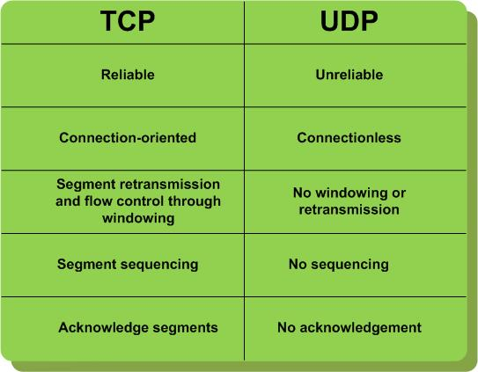
* **Hypertext Transport Protocol (HTTP):** The set of commands understood by a web server and sent from a browser
* HTTP commands: GET, POST, PUT: to update , DELETE
* **Web server:** software that listens for web page requests.

E.g Apache ,Microsoft Internet Information Server (IIS) , nginx , GWS (Google Web Server)

* **Web browser:** fetches/displays documents from web servers

**Eg.** Mozilla Firefox, Microsoft Internet Explorer (IE) ,Apple Safari ,Google Chrome ,Opera

* **Domain Name System (DNS):**  A set of servers that map written names to IP addresses

Example: www.cs.mum.edu → 69.18.50.54

* **Uniform Resource Locator (URL):** An identifier for the location of a document on a web site example: <URL:http://www.abc.com/info/index.html>

~~~~ ~~~~~~~ ~~~~~~~~~~

protocol host path

Upon entering this URL into the browser, it would:

• Ask the DNS server for the IP address of [www.abc.com](http://www.abc.com)

• Connect to that IP address at port 80

• Ask the server to GET /info/index.html

• Display the result page on the screen

* **More advanced URLs**

**• Anchor**: jumps to a given section of a web

**• Port:** for web servers on ports other than the default 80

**• Query string:** a set of parameters passed to a web program

* **HTTP status codes**

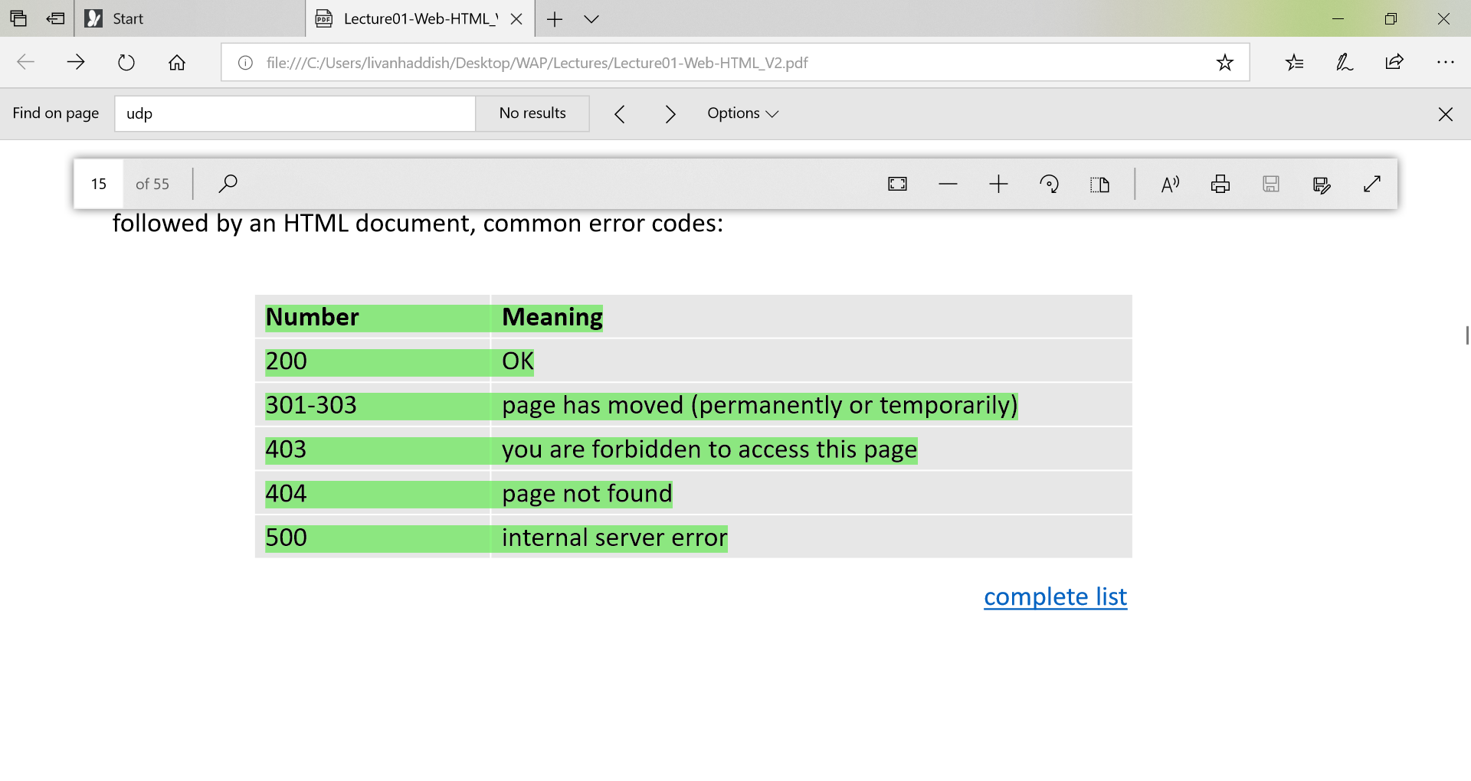

* **History Of HTTP/1.1**

HTTP is an old protocol with the last major revision HTTP/1.1 published in 1999.

HTTP/1.1 does not perform well when retrieving the large number of resources required to display a modern website.

* **How browsers display a webpage**

• User machines have IP on the Internet

• Server machines have IP and Domain Name

• Domain names and IP addresses are registered at global DNS Server

• When the user opens a browser window and ask for [www.test.com](http://www.test.com)

• First, the browser will check the local DNS (host file) for the IP address of that domain

• If not found, it will connect to ISP and ask it for the DNS

• Once retrieved, the browser will send another request to that server

• Requests are carried by TCP protocol, and standardized by HTTP or HTTPS protocol

• The server will send the browser a response with HTML code.

• The browser will interpret the HTML code line by line and start building the web page.

• For every resource not found in the browser cache, the browser will send a new request to the server again asking for that resource and so on.

* **Hypertext Markup Language (HTML):** Describes the content and structure of information on a web page
* **Element:** tag's name in html file.
* **Structure of an HTML5 page**

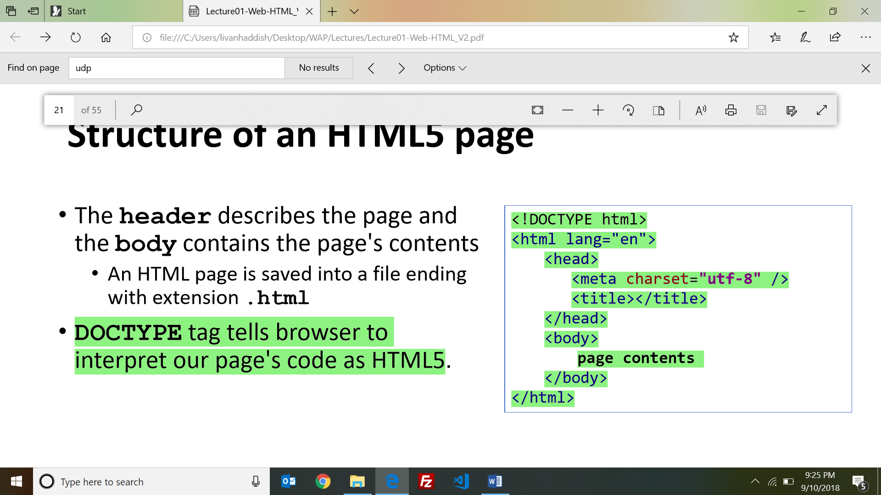

* The **meta tag** with charset attribute indicates language/character encodings
* **Favorites icon ("favicon"):** an icon to be placed in the browser title bar and bookmarks

**Eg.** <link href="yahoo.gif" type="image/gif" rel="shortcut icon" />

* **Block elements :**cover an entire large region of content **.** Examples: <div>, <p>, <table>
* **Inline elements:** affect a small amount of content . Examples: <span>, <a>, <img>
* **Links: <a> :** Links, or "anchors", to other pages (inline) .

**eg. <a href="index.php">Lecture Notes</a>.**

* **Images: <img>:**Inserts a graphical image into the page (inline)

**Eg.** <img src="../images/WhiteLily.jpg" alt="White Lily" />

* **<blockquote>:** used for A lengthy quotation (block)
* **Inline quotations: <q>** : used for inline quote

**E**.g <p>Quoth the Raven, <q>Nevermore.</q></p> =>> Quoth the Raven, “Nevermore.”

HTML shouldn't contain literal quotation mark characters; they should be written as &quot;

* **Abbreviations: <abbr>** E.g <abbr title="world wide web ">WWW</abbr>
* **Computer code: <code>:**A short section of computer code

**Eg.** <p> The <code>ul</code> tags make unordered lists. </p>

* **Preformatted text: <pre>** : used for A large section of pre-formatted text (block)
* **<em>:** emphasized text (usually rendered in italic)
* **<strong>:** strongly emphasized text (usually rendered in bold)
* **Semantic Tags:** They generally have no default outward appearance on the page, instead they give insight into the structure of the page. E.g. section • header • footer • nav • aside • article
* **Displaying List Items: •** Unordered List **•** Ordered List• Definition List
* **Definition list: <dl>, <dt>, <dd>**

**• dl** represents a list of definitions of terms (block)

**• dt** represents each term, and **dd** its definition

**Example :** <dl>

<dt>newbie</dt> <dd>one who does not have mad skills</dd>

</dl>

Output : newbie

one who does not have mad skills

* **HTML tables: <table>, <tr>, <td>**

<table>

<tr><td>1,1</td> ></tr>

</table>

* **Table headers, captions: <th>, <caption>**

A caption at the start of the table labels its meaning

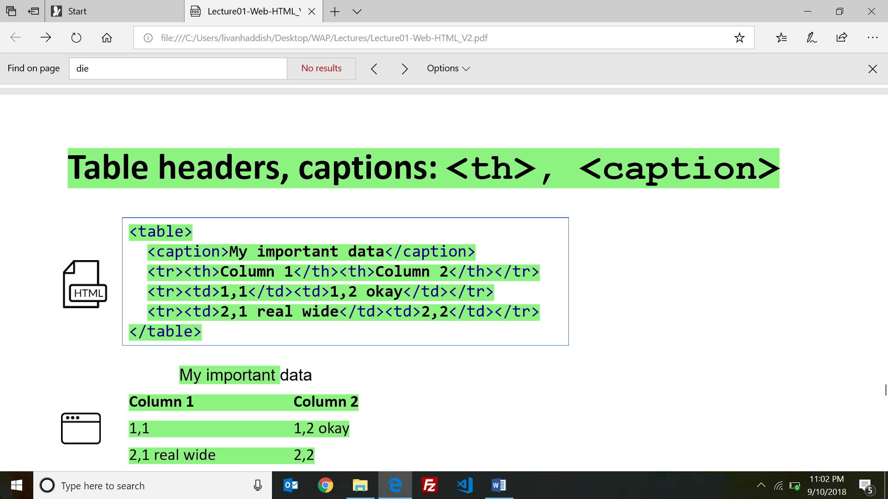

* Reserved characters in HTML must be replaced with character entities.

E.g : **< >** &lt; &gt;

**" &** &quot; &amp;

**™ ©** &trade; &copy;

* **Why is it important to adhere standards?**

• More compatibility across different web browsers

• More likely that our pages will display correctly in the future

• Can be interchanged with other XML data

* **Hypertext Markup Language (HTML):** used for writing web pages
* **Cascading Style Sheets (CSS**): stylistic info for web pages
* **JavaScript:** interactive and programmable web pages

**================================================================================**

**LECTURE 2 - CSS**

* **Linking external stylesheet**

<link href="style.css" type="text/css" rel="stylesheet" />

* **CSS:** It's called Cascading Style Sheets because the properties of an element cascade together in this order:

1. Browser's default styles

2. External style sheet files (in a <link> tag)

3. Internal style sheets (in a <style> tag in the page header)

4. Inline style (the style attribute of an HTML element)

* Placing a generic font name at the end of your font-family value ensures that every computer will use a valid font.E.g Serif, monospace..
* Size Units :

• pixels (px), point (pt), ……..

• x-small, small, medium, ……………….

• percentage font sizes. Eg 90%........

* **Viewport** is the browser window size.
* **@font-face :** allows you to specify font files.

**e.**g . @font-face {

font-family: myFont;

src: url('chap03/Purisa.ttf');

}

p {

font-family: myFont; }

* **CSS properties for fonts:** font-size, font-weight, font-style….
* **CSS properties for text**: text-decoration, text-align,…..
* **Background**

**e.g .** background-image: url("../images/draft.jpg");

background-repeat: repeat-x;

* **Opacity:** The opacity property sets the opacity level for an element. Value ranges from 1.0 (opaque) to 0.0 (transparent) . e.g div { opacity: 0.5; }
* **Specifying colors:** • Color names, • RGB & RGBA codes • HEX codes
* **CSS properties for borders: e.g** border: border-width border-style border-color;

**E.g .** border-radius:

* By default, the overall table has a separate border from each cell inside, the **border-collapse** property merges these borders into one.

e.g table { border-collapse: collapse; }

* **Column styles: <col>, <colgroup>**

**• col tag** can be used to define styles that apply to an entire column (self-closing)

**• colgroup tag** applies a style to a group of columns

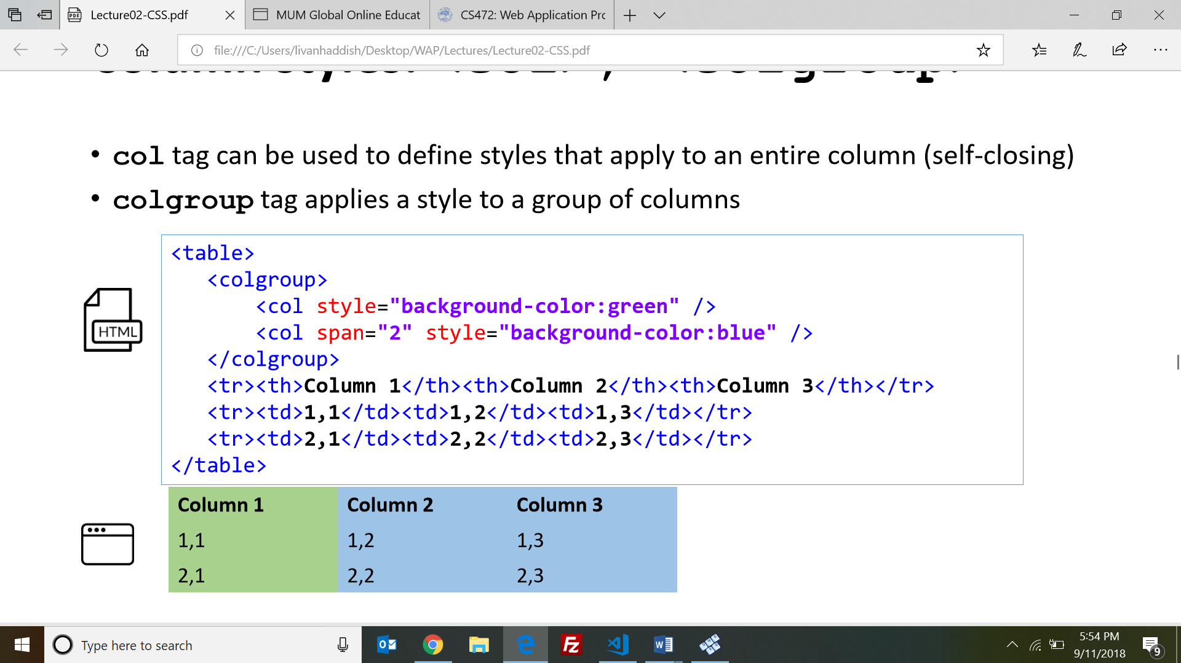

* **CSS pseudo-classes pseudo-elements**

**:: pseudo-element** : is used to style specified parts of an element. E.g. ::first-letter, ::first-line

**: pseudo-class :** is used to define a special state of an element. E.g. :hover, :focus, :first-child,

:nth-child(N), :link

Example: Specify a background color for every <p> element that is the second child of its parent**: sol:** p:nth-child(2) { background: red; }

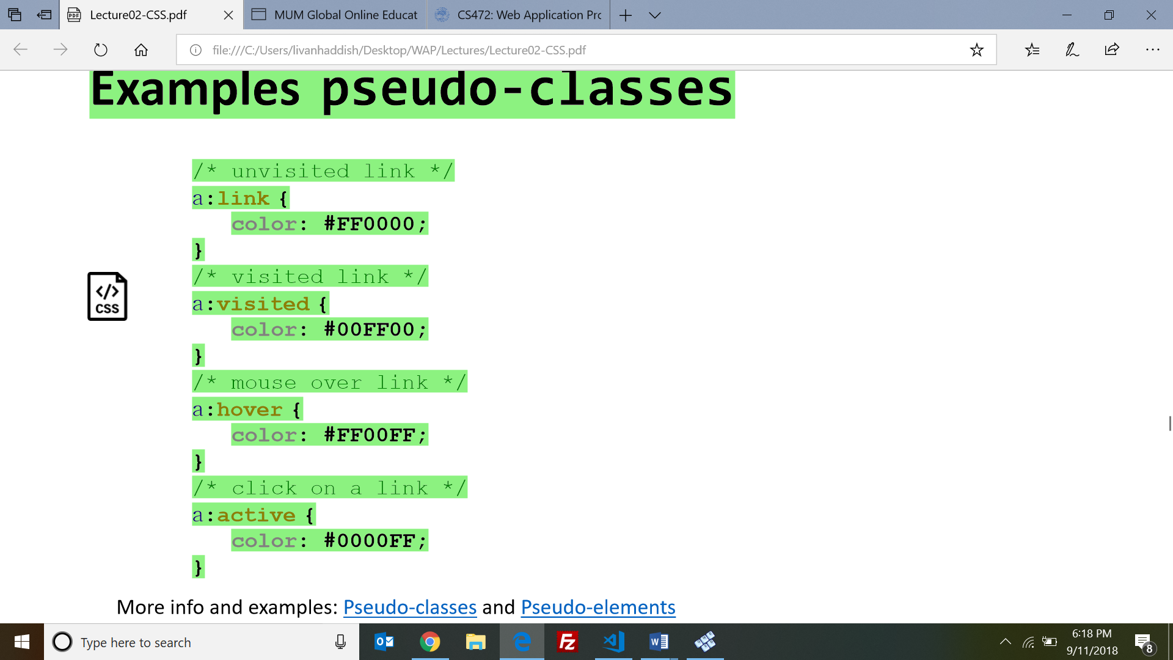

* **CSS Combinators**

**•** Descendent selector (space) – E.g div p { background-color: yellow; }

• Child selector (>) – eg. div > p { background-color: yellow; }

• Adjacent sibling selector (+) – e.g. div + p { background-color: yellow; }

• General sibling selector (~) – e.g. div ~ p { background-color: yellow; }

* **Style Specificity :** When multiple styles apply to an element and have the same origin precedence. The most specific one applies.
* **W3C CSS Validator :** Checks your CSS to make sure it meets the official CSS specifications
* **CSS3 Multiple Columns :** let you easily make multi-column text.

**e.**g .three-column

{ padding: 1em;

column-count: 3;

column-gap: 1em;

}

* How a page is displayed is affected by both the HTML and the CSS.

==============================================================================

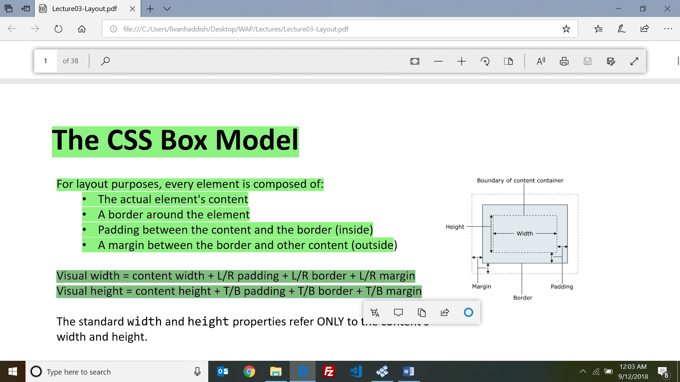

**LECTURE 3 - LAYOUT**

* **The CSS Box Model:**

• The actual element's content

• A border around the element

• Padding between the content and the border (inside)

• A margin between the border and other content (outside)

* **Visual width** = content width + L/R padding + L/R border + L/R margin
* **Visual height** = content height + T/B padd
* ing + T/B border + T/B margin
* **max-width** improves the browser's handling of small windows. This is important when making a site usable on small devices; it will avoid creating scroll bars.
* Padding shares the background color of the element.

e.g . padding:10px 5px 15px 20px;

* Margins are always transparent.
* **Margin Collapse**
* If top and bottom collapse: the bigger margin point is taken.
* If left and right collapse: the margin difference is added.
* **box-sizing**

When you set **box-sizing: border-box;** on an element, the padding and border of that element no longer increase its width.

* For inline elements only the left and right margin and padding affect surrounding elements.
* The **vertical-align** property. E.g img{ vertical-align: baseline; }
* By default block elements take the entire width space of the page and the height of its content unless we specify (width, height).
* text-align does not align block element within the page.; instead it align text (inline elements) inside the block element.
* For inline Elements, margin-top and margin-bottom are ignored
* **The display** property specifies if/how an element is displayed.

Lists and other block elements can be displayed inline, flow left-to-right on same line.

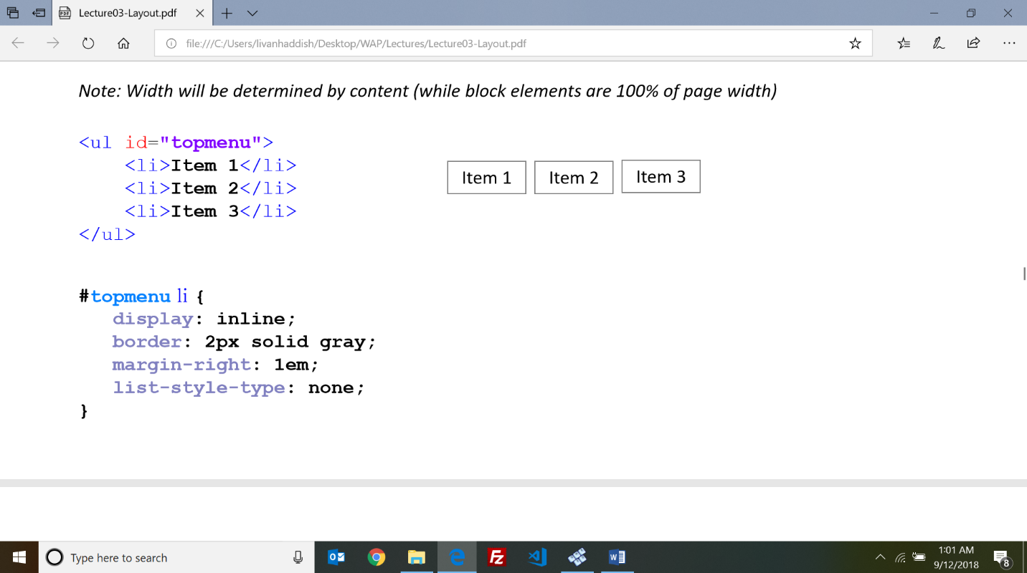e.g. #topmenu li { display: inline; border: 2px solid gray; }

* **Visibility vs display**

Setting display to none will render the page as though the element does not exist.

visibility: hidden; will hide the element, but the element will still take up the space it would if it was fully visible.

* **Positioning**
* **position: static:** is the default value of position property. It means that an element isn’t positioned. In order to position it, we have to change its predefined type to one of the following: • relative, absolute, fixed, sticky
* **position: relative;** relative behaves the same as static unless you add some offsets
* **position: fixed:** A fixed element is positioned relative to the viewport, which means it always stays in the same place even if the page is scrolled.
* **position: absolute:**
* Static positioning flows box elements from top to bottom, and inline elements from left to right. Relative positioning keeps the space in the original flow, but displays the element at an offset. Absolute positioning takes the element out of the flow and places it relative to the "containing element". Fixed positioning takes the element out of the flow and places it relative to the browser window
* **Float** . E.g img { float: right; margin: 0 0 1em 1em; }
* **overflow: auto**; used If an element overflows its content.
* **Clear** : used to control the behavior of element after a floating element. E.g .after-box { clear: left; } . The clear property specifies on which sides of an element floating elements are not allowed to float
* **Responsive Design** is the strategy of making a site that responds to the browser and device width.

**E.g.** @media screen and (min-width:600px) { nav { float: left; width: 25%; } section { margin-left: 25%; } }

@media screen and (max-width:599px) { nav li { display: inline; } }

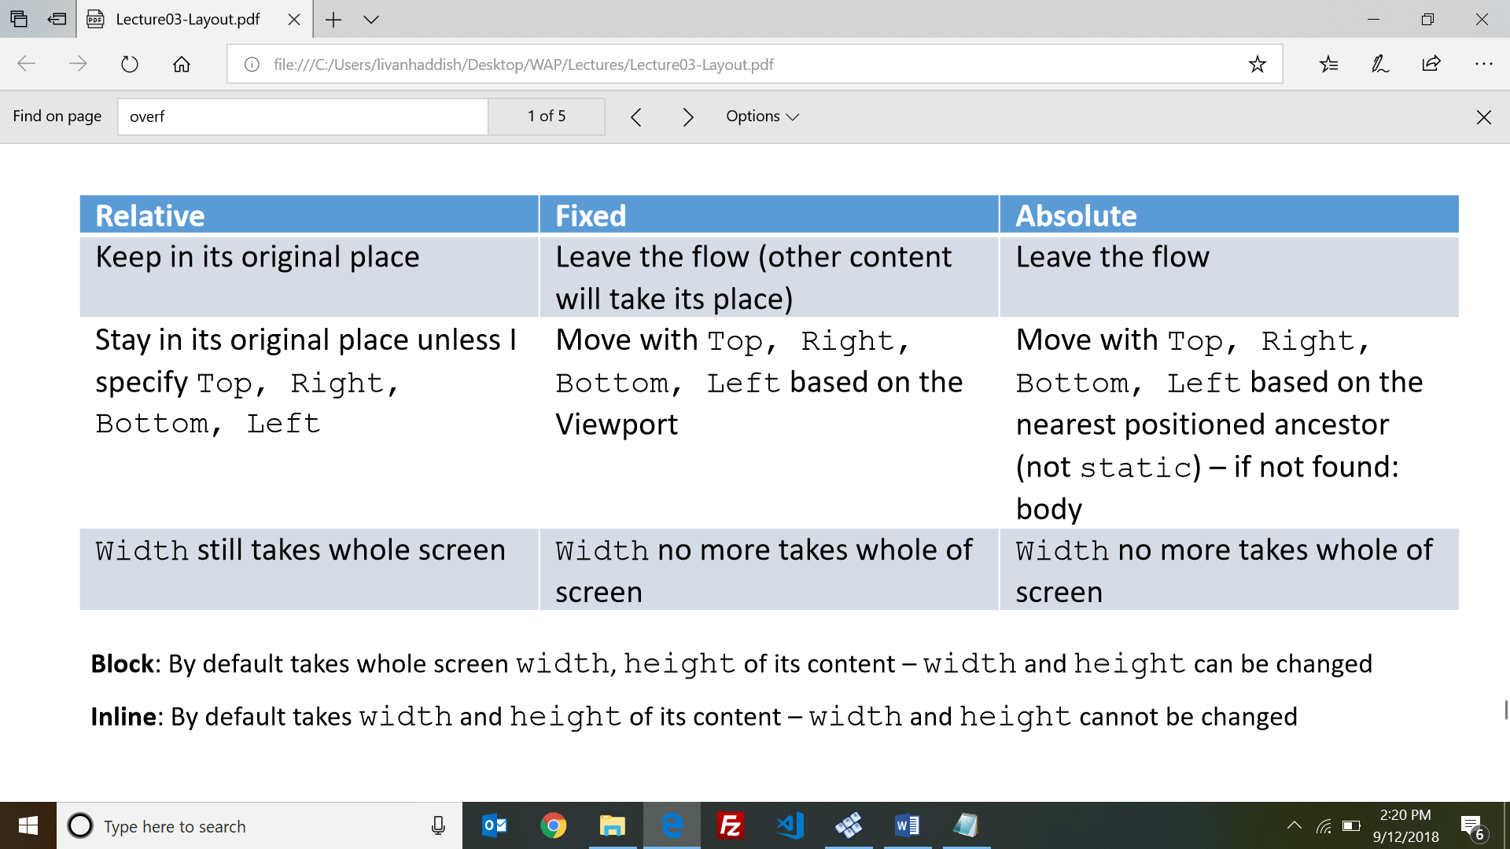

* **Block:** By default takes whole screen width, height of its content – width and height can be changed
* **Inline:** By default takes width and height of its content – width and height cannot be changed
* CSS Frameworks: Bootstrap, blueprint,foundation,semanticUI
* **Browser CSS Reset code :** * { margin: 0; padding: 0; font-size: 100%; }

**=====================================================================================**

**LECTURE 4 – FORMS AND REGEX**

* An **HTML form** allows the user to send data (parameters) to the server. Forms are created with the <form> tag, and can be submitted with either an HTTP GET or POST method
* We can have multiple forms on a single webpage, but forms CANNOT be nested.
* Form example:

<form action="http://www.google.com/search">

<div> Let's search Google <input name="q" /> <input type="submit" /></div>

</form>

* **Query string:** a set of parameters passed from a browser to a web server
* URLs are limited in length (~ 1024 characters)
* For POST requests, parameters are embedded in the HTTP request body, not the URL. More secure than GET for this reason only.
* 3 ways to send a request from a browser tab to the server:

• Type url (GET) • Form (GET, POST) • Using JavaScript

* **<input /> :** input element is used to create inline input element and MUST be self-closed
* **type** attribute can be button, checkbox …..
* **value** attribute specifies control's initial text
* **placeholder** (HTML5) a short hint that describes the expected value of an <input> element
* The **<textarea>** tag defines a multi-line text input control.

E.g <textarea rows="4" cols="20"> Type your comments here. </textarea>

* Use the checked attribute in HTML to initially check the box

E.g <input type="checkbox" name="tomato" checked /> Tomato

* Radio button have the same “name” for all choices; and value is different as per choice.

E.g <input type="radio" name="cc" value="visa" checked /> Visa

<input type="radio" name="cc" value="mastercard" /> MasterCard

* **<label> :** label element can be targeted by CSS style rules

**E.**g. <label><input type="radio" name="cc" value="mastercard" /> MasterCard</label>

* **Drop-down list : <select> and <option>**

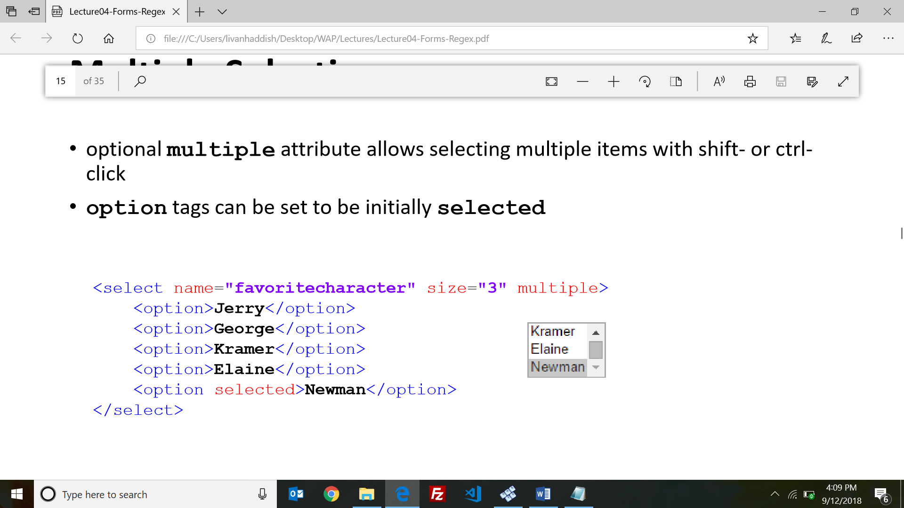**E.g** <select name="favoritecharacter" size="2" multiple>

<option>Kramer</option>

<option selected>Newman</option>

</select>

* **selected** attribute sets which one is initially chosen
* **multiple** attribute allows selecting multiple items with shift- or ctrl click
* 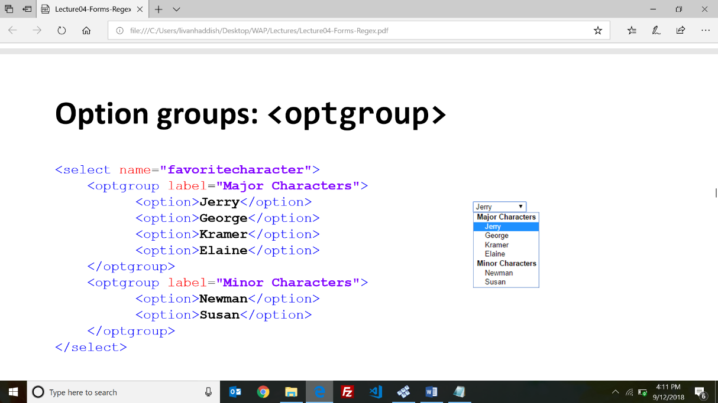**Option groups: <optgroup>**
* 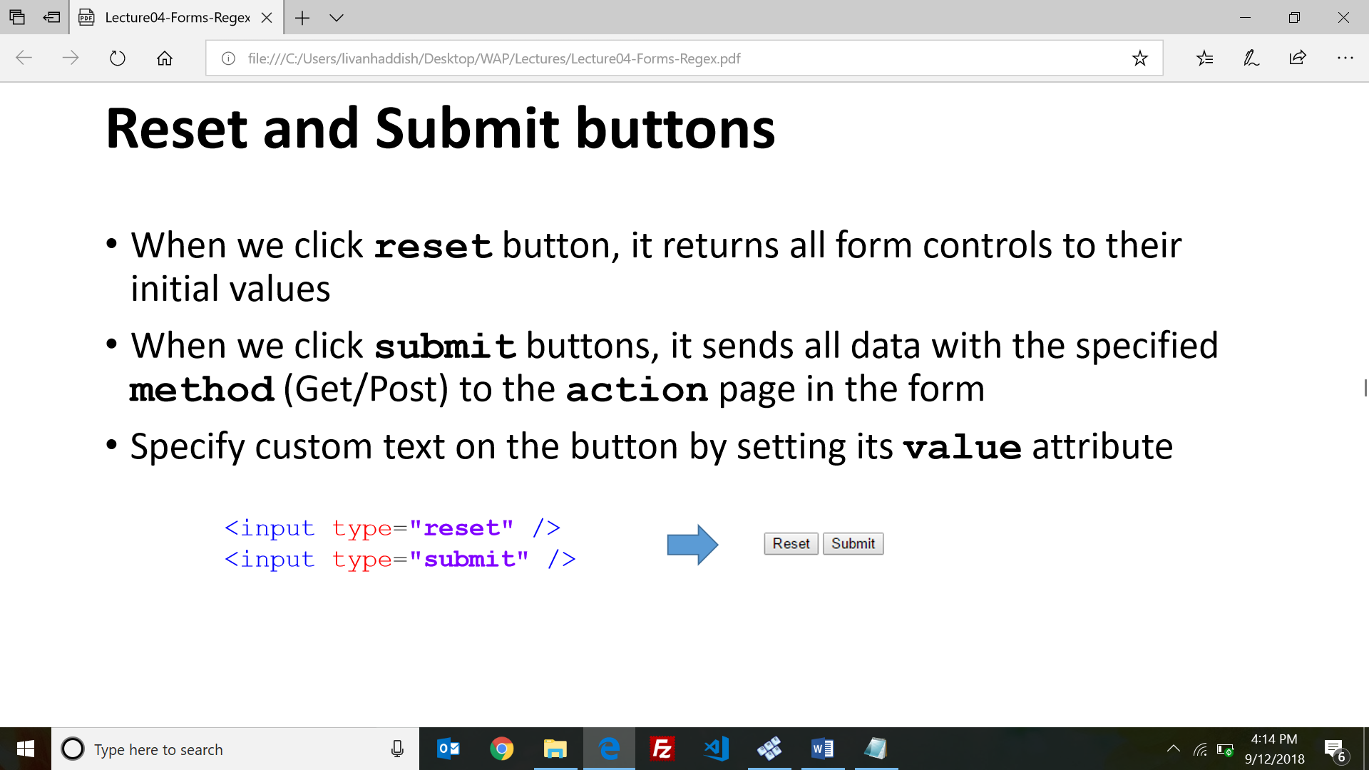**Reset and Submit buttons :** <input type="reset" /> <input type="submit" />
* **Hidden input parameters:** An invisible parameter that is still passed to the server when form is submitted, it’s useful for passing on additional state that isn't modified by the user

**E.**g <input type="text" name="sid" /> SID <br />

<input type="hidden" name="school" value="MUM" />

* **Grouping : <fieldset>, <legend>**

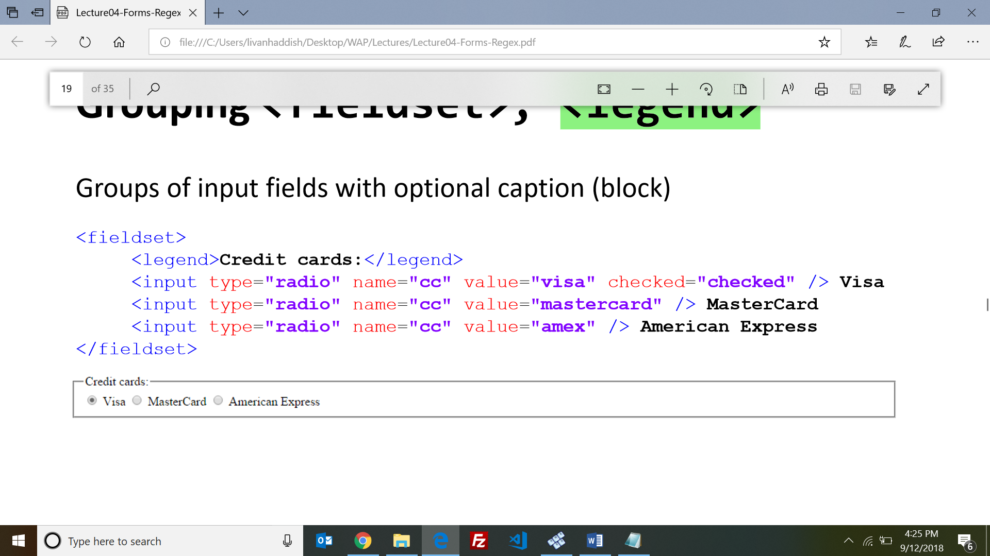

* **Styling form controls**

Because most input element are created using input tag, we target each group of elements using this CSS selector: element[attribute="value"] { property : value; ... }

E.g input[type="text"] { background-color: yellow; font-weight: bold; }

* The **pattern** attribute specifies a regular expression that the <input> element's value is checked against. E.g <input type="text" name="countrycode" pattern="[A-Za-z]{3}" title="country code">
* **Anchors: ^ and $**

**^** represents the beginning of the string or line;

**$** represents the end

* **Wildcards . :** A **dot .** matches exactly one-character except a \n .

E.g **.oo.y** matches "Doocy", "goofy", "LooNy", ...

* **Special characters: |, (), \**
* **quantifiers: {min,max}**
* **Character sets: [] :** will match any single character from the set

**E.**g. [bcd]art matches strings containing "bart", "cart", and "dart"

* **Character ranges**: [**start-end] .** E.g [a-z] matches any lowercase letter
* an initial **^** inside a character set negates it . E.g [^abcd] matches any character other than a, b, c, or d
* **Escape sequences : \d, \w…..**

E.g $100.00 = > \$[1-9]\d{2,}\.\d{2}

E.g email => ^[a-zA-Z_\-]+@(([a-zA-Z_\-])+\.)+[a-zA-Z]{2,4}$

**=====================================================================================**

**LECTURE 5 - JAVESCRIPT**

* **JavaScript:** A lightweight programming language ("scripting language") Used to make web pages interactive
* **JavaScript vs. Java**

• Interpreted, not compiled

• More relaxed syntax and rules

• Key construct is the function rather than the class

• Powerful and lightweight

• OO language that does not have classes

• Contained within a web page and integrates with its HTML/CSS content

• Many pitfalls Alert

* can find out a variable's type by calling **typeof(variable_name);**
* **Primitive type:** is a type that’s represented as a single value (not object) .E.g undefined, null, Boolean……
* Many operators auto-convert types: "2" * 3 is 6
* Many operators auto-convert types: E.g "2" * 3 is 6
* var n2 = parseFloat("booyah"); // NaN
* **unshift** and **shift** add / remove from front
* **shift** and **pop** return the element that is removed
* **Special values: null and undefined:**

**• undefined:** has been declared, but no value assigned

**• null:** var exists, and was explicitly assigned an value of null

* **JavaScript Object:** A collection of name/value pairs
* **Document Object Model (DOM)**

All HTML elements are represented in browsers as objects • All objects are nested together in one tree (DOM tree)

Access/modify the attributes of the DOM object with **objectName.propertyName**

* **Global Environment and Global Objects**

**The global environment** is a wrapper to your code.

**Global objects are**: window( is the default), document, history, location , navigator, screen

• The **window** object the top-level object in hierarchy

• The **document** object the root of HTML document and the "owner" of all other nodes.

• The **location** object the URL of the current web page

• The **navigator** object information about the web browser application

• The **screen** object information about the client's display screen

• The **history** object the list of sites the browser has visited in this window

* **window.open** pops up a new browser window
* **Accessing the DOM**- **document.getElementById** returns the DOM object for an element with a given id
* Style properties are written in camelCasedNames
* To change a DOM element style we use **style** property which allows you to set any CSS style property. **E.g element.style.fontSize="14pt";**
* **Common DOM styling errors:**
* forget to write **.style** when setting styles
* style properties are capitalized as camelCasedNames
* style properties must be set as strings, often with units at the end
* **JS Timers:**
* **setTimeout(function, delayMS);** arranges to call given function after given delay in ms
* **setInterval(function, delayMS);** arranges to call function repeatedly every delayMS ms
* clearTimeout(timerID) and clearInterval(timerID) to stop the given timer.
* **Common Timer Error**

setTimeout(multiply(num1 , num2), 5000); this is wrong

setTimeout(multiply, 5000, num1, num2); right way to write it

* **Linking to a JavaScript file:** <script src="filename" type="text/javascript"></script>
* In JavaScript, the **lexical environment** is where the code is sitting physically.
* **Code Execution and Hoisting**

• When your code is being executed, the JS engine in the browser will create the global environment objects and start looking in your code for functions and variables.

• In the **first phase**, JS engine will reserve special memory space for functions (as whole), while it reserves memory only to variables names. All variables are initially set to undefined. (Hoisting)

• In **second phase**, JS engine will execute your code line-by-line and call all functions and create execution context for every function (scope) in the execution stack.

* If you assign a value to a variable without var, JS assumes you want a new global variable
* To execute code wen user clicks on an element, add JavaScript code to an HTML event attribute:

E.g . <button onclick="sayHi()">Say Hi!</button>

===================================================================================

**LECTURE 6 – SCOPE CHAIN**

* **Scope:** The enclosing context where values and expressions are associated
* Functions in JS define a new scope
* Writing **"use strict";** at the very top of your JS file (or function) turns on strict syntax checking:
* **var** scope is defined by the nearest function block
* **let** scope is defined by the nearest enclosing block
* **var vs let**

• Use let instead of var inside for loops to prevent leaking to the outer scope.

• let, unlike var, does not create a property on the global object.

• let, unlike var, does not hoist

* The **const** declaration scoped to block, cannot be updated, NOT immutable, objects cannot change its structure but we can change the values.
* To make an object immutable we call: **Object.freeze();**
* When using **let** or **const**, there will be no hoisting and we will receive an error if used.
* **Rule of thumb:**

• Use const by default

• Only use let if you need to update your variable later

• Don’t use var

* Functions are first-class citizens:

• Assign them to variables

• Pass them around as parameters

• Create them of the fly

* Functions are objects
* Function Statement: E.g

function sayHi() { console.log('Hi'); }

sayHi();

* Function Expression: E.g

var sayHi = function() { console.log('Hi'); }

sayHi();

* Arrow functions are function shorthand using => syntax.

(arguments) => { return statement } // general syntax

argument => { return statement } // one parameter

argument => statement // implicit return

() => statement // no input

* JavaScript function calls are flexible and can be called with any number of parameters.

• If more than expected, will simply be neglected.

• If less than expected, rest will be undefined.

* Flexible function Arguments:. E.g

function display(products){

let count = products.length; // Cannot read property 'length' of undefined ... }

display();

Scalable solution Solution to the above problem:

function display(products=[]){

let size = products.length; }

display();

* **Destructuring Arrays and Objects**

**destructuring assignment syntax** is a JavaScript expression that makes it possible to extract data form arrays and objects into distinct variables

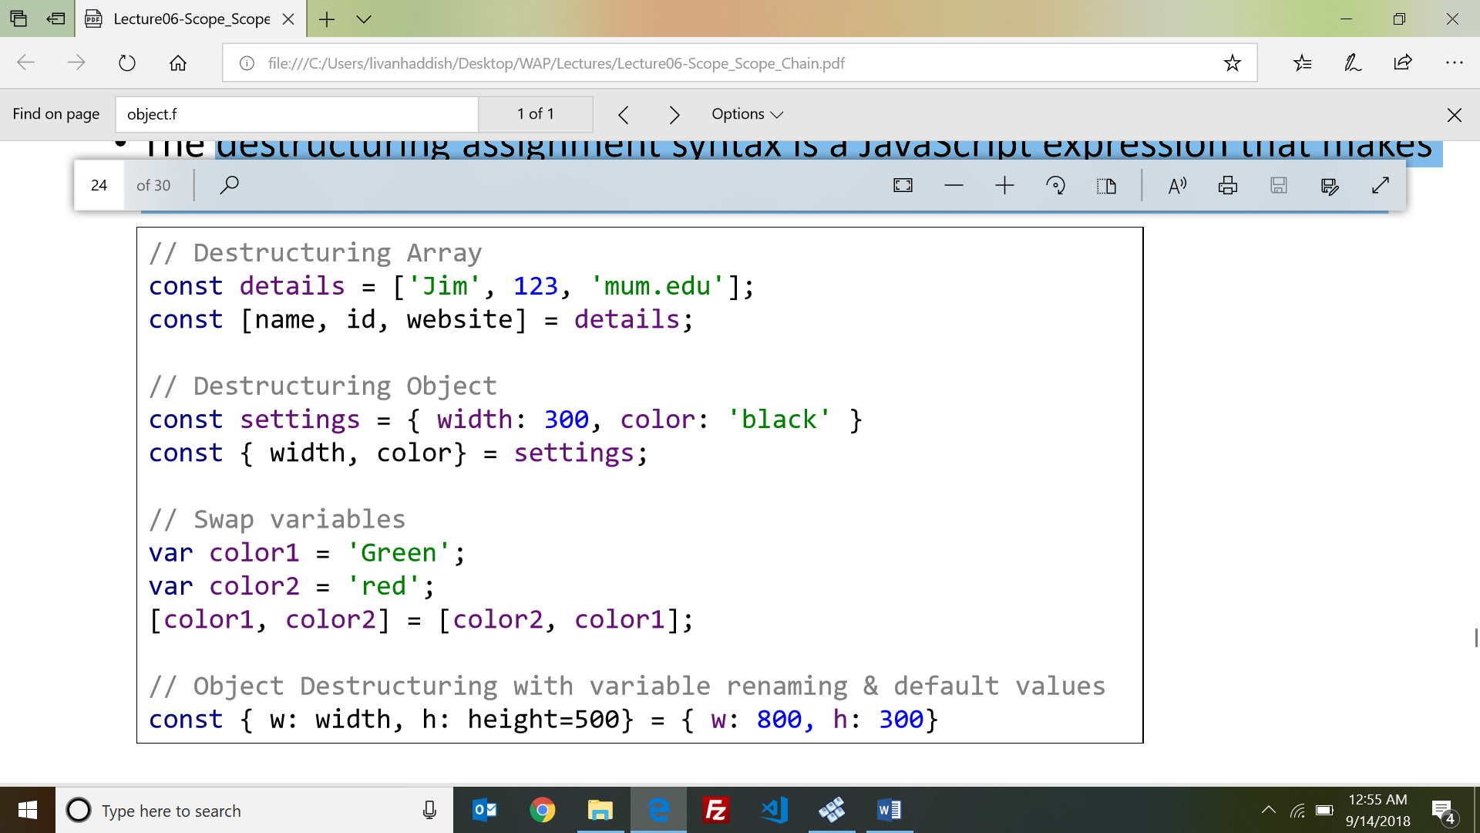

* A **Rest** syntax allows us to represent variable number of arguments as an Array.
* The **spread** syntax allows an expression to be expanded in places where multiple arguments (for function calls) or multiple elements (for array literals) or multiple variables (for destructuring assignments) are expected.

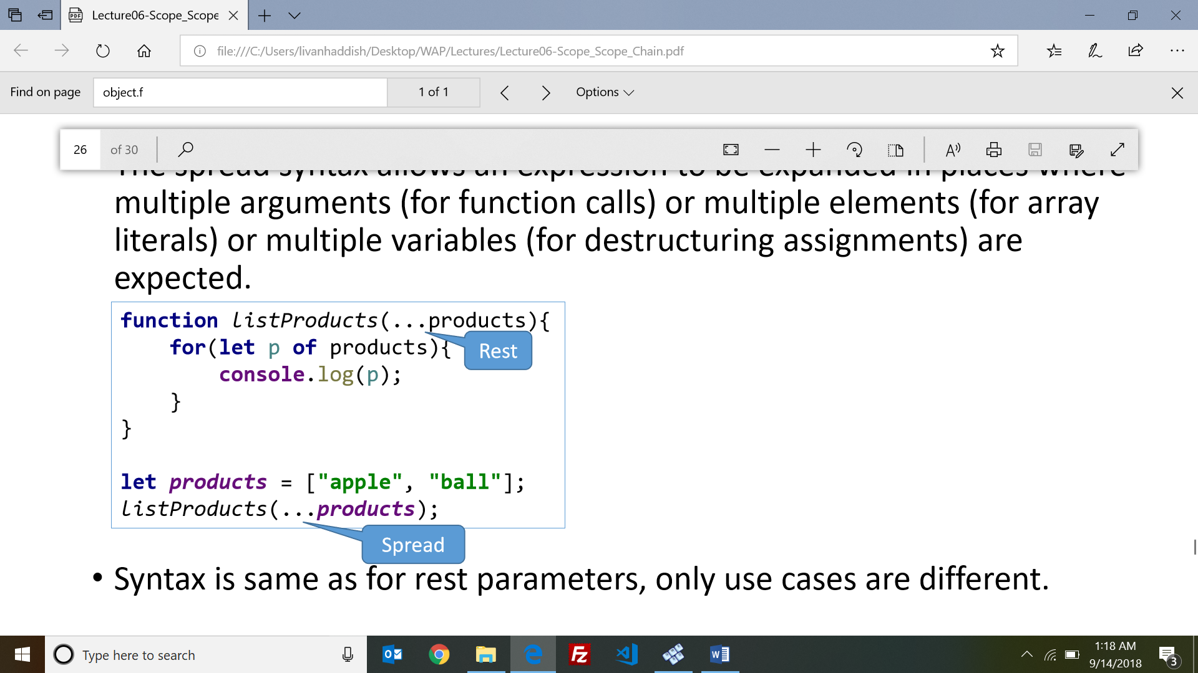

=====================================================================================

**LECTURE 7 - Events, this and callbacks / JavaScript IIFE & Closures**

* **How events work:**

**// Event handler**

function sayHello(){ document.getElementById("output").innerHTML = "Hello World"; }

Better way to bind : elementObj.onclick = sayHello;

* **Unobtrusive JavaScript:**

**•** HTML with minimal JavaScript inside

**Allows separation of web site into 3 major categories:**

• content (HTML)

• presentation (CSS)

• behavior (JavaScript)

* **Attaching an event handler in JavaScript code example:**

<button id="ok">**OK**</button>

var okButton = document.getElementById("ok");

okButton.onclick = okayClick;

function okayClick() { alert("booyah"); }

* The **window.onload** event: is a global event used to attach the handler after the page has loaded.

Example:

<button id="ok">OK</button>

function pageLoad() {

document.getElementById("ok").onclick = okayClick; }

function okayClick() { alert("booyah"); }

window.onload = pageLoad;

* **Common unobtrusive JS errors:**

1. Many mistakenly write () when attaching the handler.
2. Event names are all lowercase, not capitalized like most variables

* Changes in HTML 5

• The "type" attribute is optional

• The "async" attribute is new in HTML 5

* **“this**”in JavaScript refers to the object which ‘owns’ the method, and it depends on how a function is called.

If there’s no current object, ‘this’ refers to the global object.( window)

Example:

• f() {console.log(this)} // window;

• a.f() {console.log(this)} // a object;

* When using **this** inside an event handler, it will always refer to the invoker.
* **Ways an external script can be executed:**

1. **async="async**": The script is executed asynchronously with the rest of the page.
2. **defer="defer"**: The script is executed when the page has finished parsing
3. **neither async or defer is present:** The script is fetched and executed immediately, before the browser continues parsing the page

* **A callback function** is a function you give to another function, to be invoked later when the other function is finished (desired).
* **Closure:** A first-class function that binds to free variables that are defined in its execution environment.

Closures are created whenever an inner function is defined and it closes over its free variables. Closures provide encapsulation of methods and data. Encapsulation promotes self-sufficiency, stability, and re-usability.

* **Free variable**: A variable referred to by a function that is not one of its parameters or local variables.
* Parenthesis are an expression that wraps a function expression that will be immediately invoked **- “immediately invoked function expression (IIFE)”**

**=============================================================================**

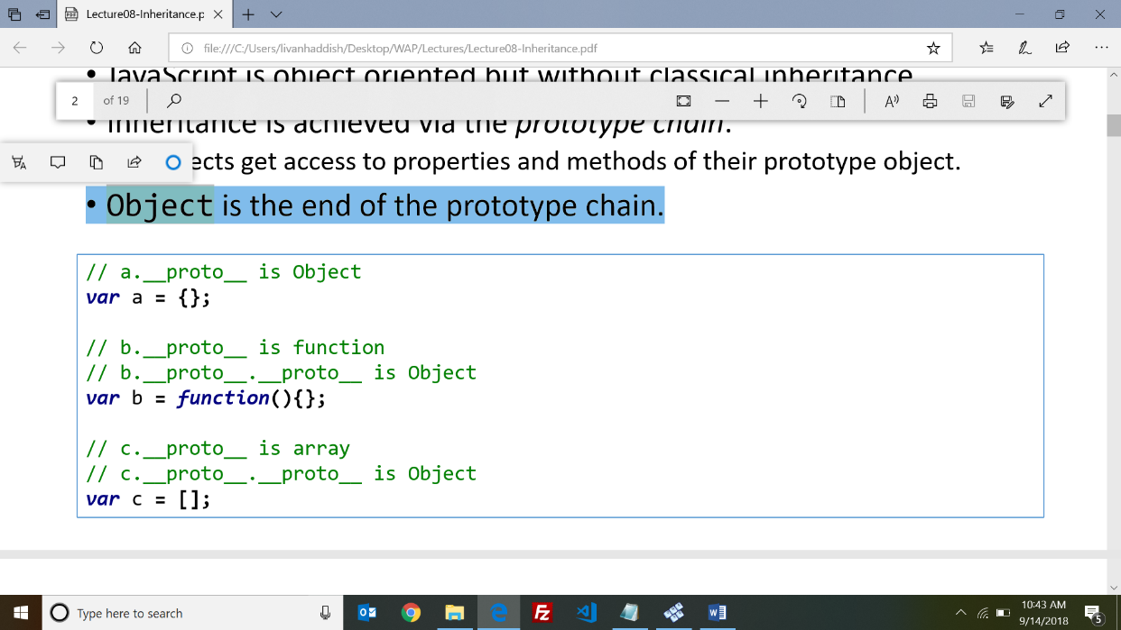**LECTURE 8 – INHERITANCE**

* JavaScript is object oriented but without classical inheritance.
* Inheritance is achieved via the prototype chain.
* Object is the end of the prototype chain.
* ES5 standardized an alternative way of prototype-based inheritance using **Object.create()** method.
* **JavaScript Object properties**
  + A JavaScript object is a collection of unordered properties.
* JavaScript object inherit the properties of their prototype
* **Constructor functions**: It’s a Function used to create/construct other Objects and doesn’t return a value.
* A property called prototype in the constructor is used to extend/add new functionalities to all objects created by the constructor using new keyword
* **How to create Objects in JS**

• From Object using: Object.create();

• From Function Constructors: new FunctionConstructor();

* In JavaScript, the thing called **this**, is the object that "owns" the JavaScript code.

• The value of this, when used in function, is the object that "owns" the function.

• The value of this, when used in an object, is the object itself.

* Use **.bind()** when you want that function to later be called with a certain context, useful in events.
* Use **.call()** or **.apply()** when you want to invoke the function immediately, and modify the context.
* Call/apply call the function immediately, whereas bind returns a function that when later executed will have the correct context set for calling the original function. This way you can maintain context in aysnc callbacks, and events.
* **Function Currying using bind()**

**•** Currying refers to the process of transforming a function with the multiple arguments into same function with less arguments.

• The curried effect is achieved by binding some of the arguments to the first function invoke, so that those values are fixed for the next invocation.

====================================================================================

**LECTURE 9 - jQuery & Event Bubbling**

* JavaScript is a powerful language, but coding to browsers is difficult:

• Code that works great in Chrome, Firefox, Safari, ... will fail in IE and vice versa

• Browsers have different implementation of specs in each version

• With the rise of mobile devices maintaining browsers compatibility becomes difficult.

* The jQuery function returns a jQuery object, which contains a collection of DOM elements for manipulation.
* **jQuery is so powerful because of these design principles**

• An expressive method for defining a set of elements

• A superset of CSS selectors

• Useful and commonly needed methods for navigating the DOM tree

• Heavily overloaded APIs

• Functional programming techniques that apply operations to sets of elements at a time

• Method chaining for succinct operations

* **Aspects of the DOM and jQuery :**

1. Identification, 2. Traversal, 3. Node Manipulation, 4. Tree Manipulation

* **jQuery $ function signatures**
* Responding to the page ready event: $(function);
* Identifying elements: $("selector", [context]);
* Upgrading DOM elements: $(elements);
* Creating new elements: $("<html>", [properties]);
* **getElementsByTagName** returns array of all elements with the given tag, such as "div".
* E.g Change the background color of all paragraphs to yellow:

<body>

<p>This is the first paragraph</p>

</body> This is jquery way : **$("p").css("background-color", "yellow");**

**jQuery Terminology**

* **The jQuery function**: Refers to the global jQuery function/object or the $ function depending on the context
* **jQuery object:** The object returned by the jQuery function that often represents a group of elements
* **Selected elements** The DOM elements that you have selected, most likely by some CSS selector passed to the jQuery function and possibly later filtered further
* When the argument to $() is a CSS selector the function will return a "jQuery object" that contains a group of selected DOM elements.
* Common bug: incorrect usage of existing styles:

E.g : // bad! : $("#main").css("top", $("#main").css("top") + 100 + "px");

The above example computes "200px" + 100 + "px" which evaluates to "200px100px"

A corrected version:

// correct : $("#main").css("top", parseInt($("#main").css("top")) + 100 + "px");

* Common jQuery mistake

// bad: jQuery $(".main").css("top", parseInt($(“.main").css("top")) + 100 + "px");

The above example does not take full advantage of jQuery syntax. Does not work if there are multiple selected objects. Why is that?

A corrected version:

// good jQuery : $(".main").css("top", function(idx, old) { return parseInt(old) + 100 + "px"; });

* When there is no other return to make, jQuery methods return the same jQuery object back to you. E.g . $("#myid"); => jQuery object
* **Creating new node**

Merely creating a element does not add it to the page. you must add the new element as a child of an existing element on the page...

* The jQuery object returned by the selection mode of $() is a collection of DOM elements wrapped by jQuery functionality. This object can read style properties as well as set them by using the css() method of jQuery.
* To abort a form submit or another event's default browser behavior, call jQuery's **preventDefault()** method on the event
* Use the **stopPropagation()** method for Stopping an event from bubbling
* Use **stopImmediatePropagation()** method for Stopping an event right now
* jQuery does something special if you return false in your event handler

1. prevents the default browser action, eg evt.preventDefault()

2. stops the event from bubbling, eg evt.stopPropagation()

===============////==================////==============////===============////=======

**MID-TERM EXAM**

===============////==================////==============////===============////=======

**LECTURE 10 – AJAX**

* **Synchronous**: user must wait while new pages load (click, wait, refresh)
* **Asynchronous:** user can keep interacting with page while data loads.
* **Web Application:** a dynamic web site that mimics the feel of a desktop app. E.g .google map,gmail….
* **Ajax:** Asynchronous JavaScript and XML

• Not a programming language; a particular way of using JavaScript

• Downloads data from a server in the background

• Allows dynamically updating a page without making the user wait

• Avoids the "click-wait-refresh" pattern . •Example: Google Suggest

* **XMLHttpRequest:**
* JavaScript includes an XMLHttpRequest object that can make requests to a web server asynchronously (in the background, transparent to user).
* The contents of the fetched file can be put into current web page using the DOM
* **Why we won't use XMLHttpRequest**

• It is clunky to use, and has various browser incompatibilities

• jQuery provides a better wrapper for Ajax, so we will use that instead.

* The key component that a browser provides to enable Ajax is the XMLHttpRequest object, which is supported by all modern browsers. This object opens a connection with a server, sends a message, waits for the response, and then activates a given callback method.
* **JavaScript Object Notation (JSON):** Data format that represents data as a set of JavaScript objects

It is supported by all modern browsers and is more popular than XML due to its simplicity and ease of use.

* JSON is a syntax for storing and exchanging data and an efficient alternative to XML
* You can use Ajax to fetch data that is in JSON format ,then call JSON.parse on it to convert it into an object, then interact with that object as you would with any other JavaScript object
* **JSON.parse(string):** this method converts the given string of JSON data into an equivalent JavaScript object and returns it
* **JSON.stringify(object)**: this method converts the given object into a string of JSON data (the opposite of JSON.parse).
* **jQuery's ajax method:**

• Call the $.ajax() method

• Constructor accepts an object literal full of options that dictate the behavior of the AJAX request,

the url to fetch, as a String, the type of the request(GET or POST)…..etc

* **$.ajax() options** are: url, type, data, timeout, success, error, complete
* **jQuery's ajax example:**

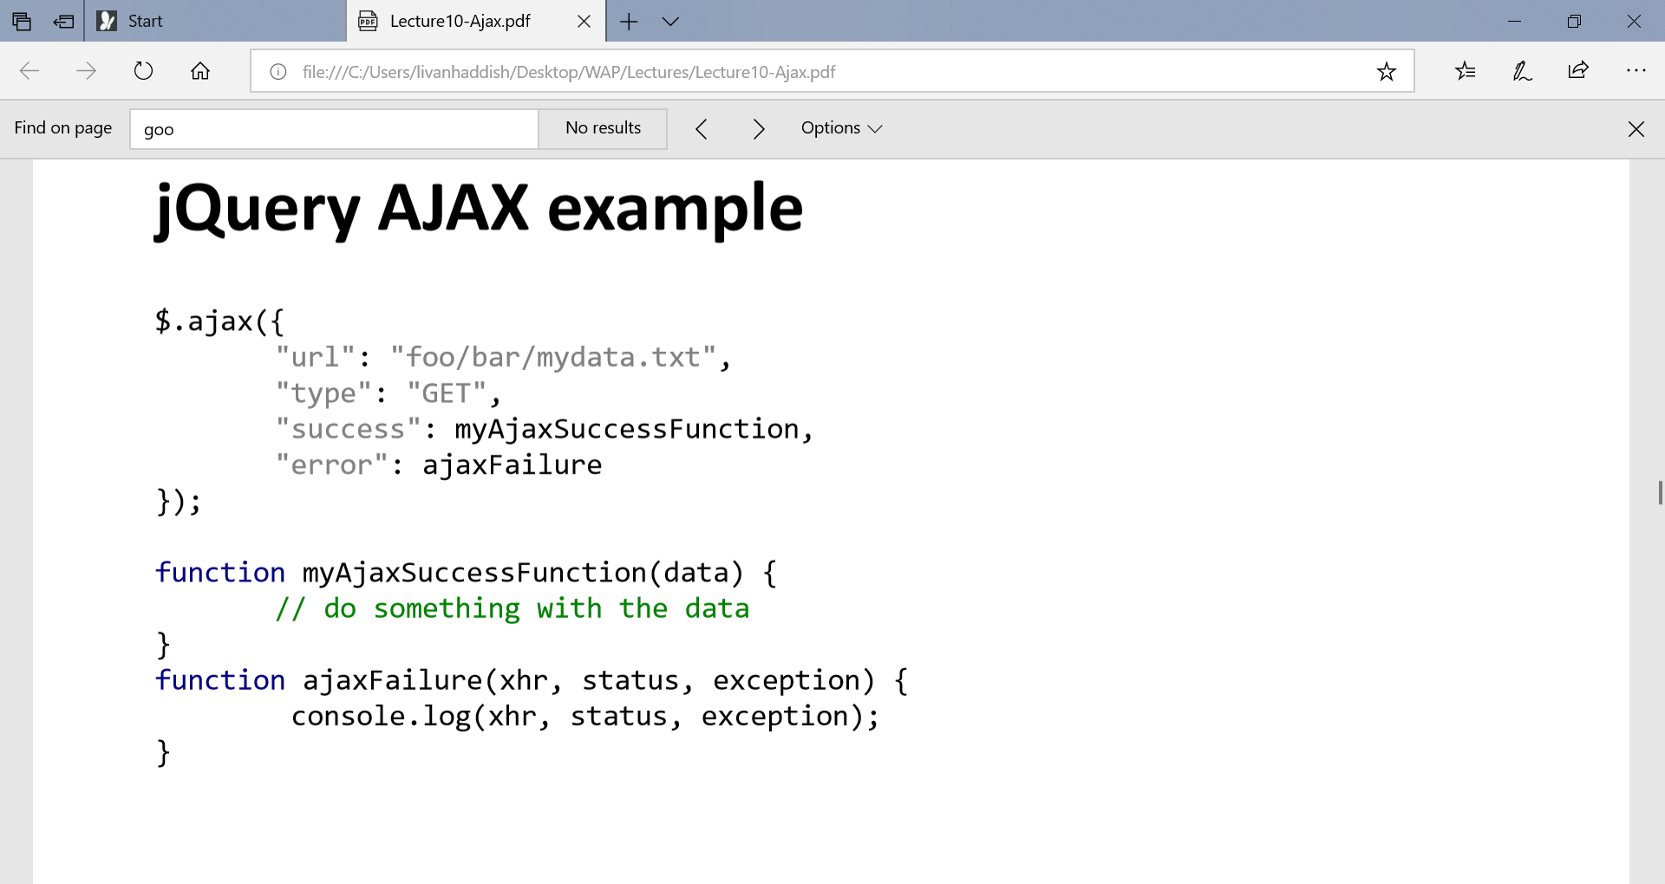

* we can pass the URL as the first parameter and the rest as an object literal to makes it even easier to see what this AJAX request is doing.

E.g $.ajax("http://foo.com", { "type": "GET",

"success": functionName,

"error": ajaxFailure });

* Even Better jQuery AJAX would be using these event handler function calls done() and fail() instead.

$.ajax("http://foo.com", { "type": "GET" })

.done(functionName)

.fail(ajaxFailure);

* For POST request, type should be changed to "POST" (GET is default)
* These shortcut functions are preferred when additional options are not needed.
* $.get(url, {data}) .done(function) .fail(function);
* $.post(url, {data}) .done(function) .fail(function);

**$.ajax()** A general function for making AJAX requests, other AJAX functions rely on this

**$.get()** makes a GET request via AJAX

**$.post()** makes a POST request via AJAX

* The browser console window is critical to debugging Ajax code since it allows the developer to easily see the request that was sent and the response that was returned.
* The same origin policy is a security constraint on browsers that restricts scripts to only contact a site with the same domain name, application protocol, and port. This means that browsers only allow Ajax calls to the same web server from which the page originated

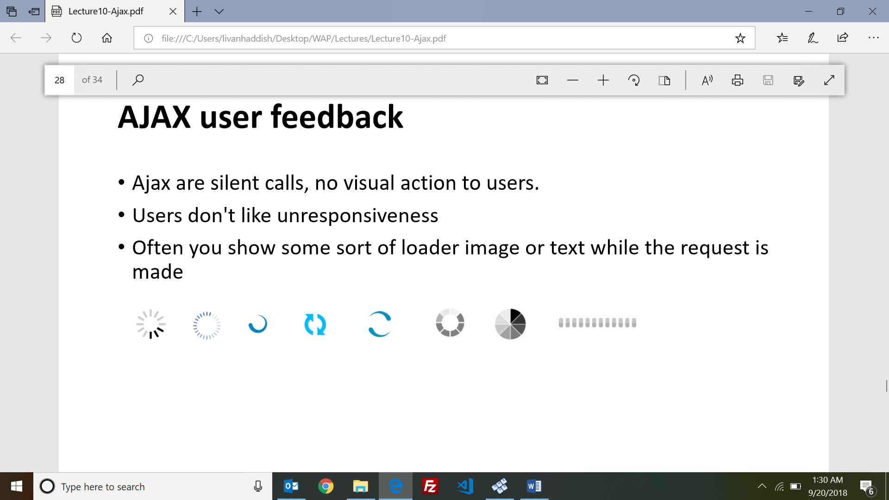

* Ajax are silent calls, no visual action to users.

**User feedback with always()**

* The general technique is to **show()**some feedback when the AJAX request starts and **hide()** it again once it finishes.
* The **always()function** is an event that the AJAX request fires every time the request finishes, whether it was successful or not.

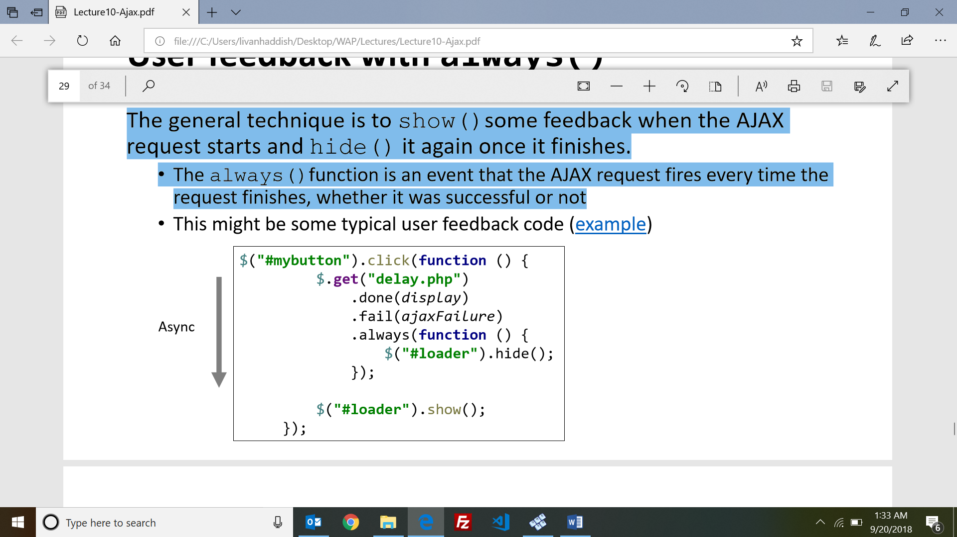

* Ajax allows JavaScript to access the server in a very efficient manner using asynchronous messaging and partial page refreshing.
* JSON has become more widely used for Ajax data representations than XML because JSON is easier to write and read and is almost identical to JavaScript object literal syntax.

=================================================================================

**LECTURE 11 - Servlets and Web Containers**

* **Web Dynamics:** Interaction between a browser (client) and a web server
* **Steps**: 1. User clicks a link or button in browser 2. Browser formats request and sends to server 3. Server interprets request and attempts to locate resource 4. Server formats a response and sends to browser 5. Browser renders response into a display for user
* A web server serves static content – text files, images, pdfs, videos, exactly as they are on the server machine
* A web server on its own can’t handle behavior like log in, online shopping…..and can’t also save data to the server.
* **A Servlet** is server-side java code (class) that can handle http requests and return dynamic content in http response.
* Servlets are managed by a servlet engine or container.
* A servlet is a Java class that extends the capabilities of servers that host applications access by means of a request-response programming model.
* Most commercial web applications use Apache web server
* Tomcat can act as simple servlet web container

**Servlet Hierarchy**

**• Servlet :** • service() • init() • destroy()

**• GenericServlet**

**• HttpServlet:** • doGet() • doPost() • doPut() • doHead() • doDelete() • doTrace()

* **My Servlet**

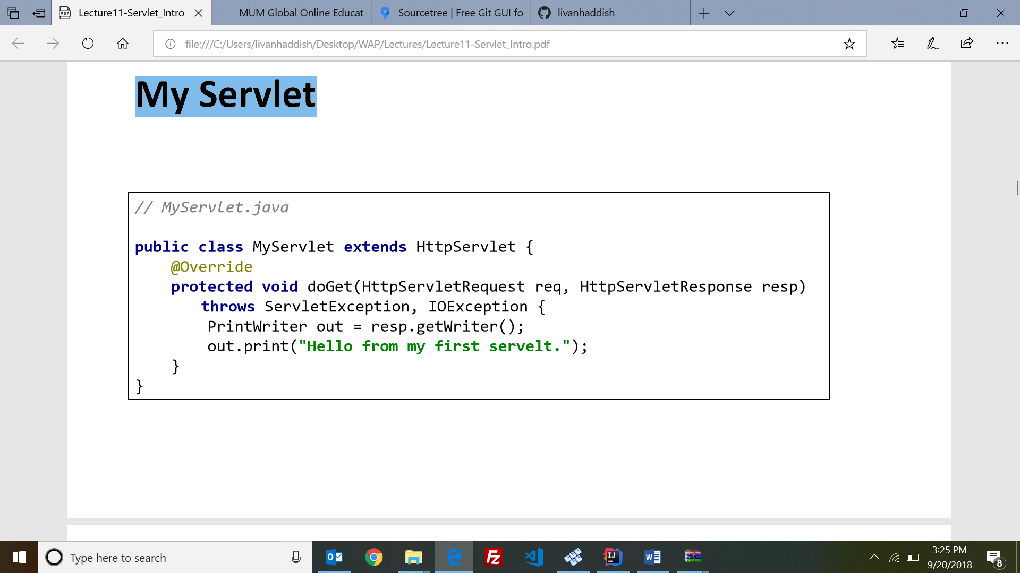

* **Servlet mapping using web.xml**

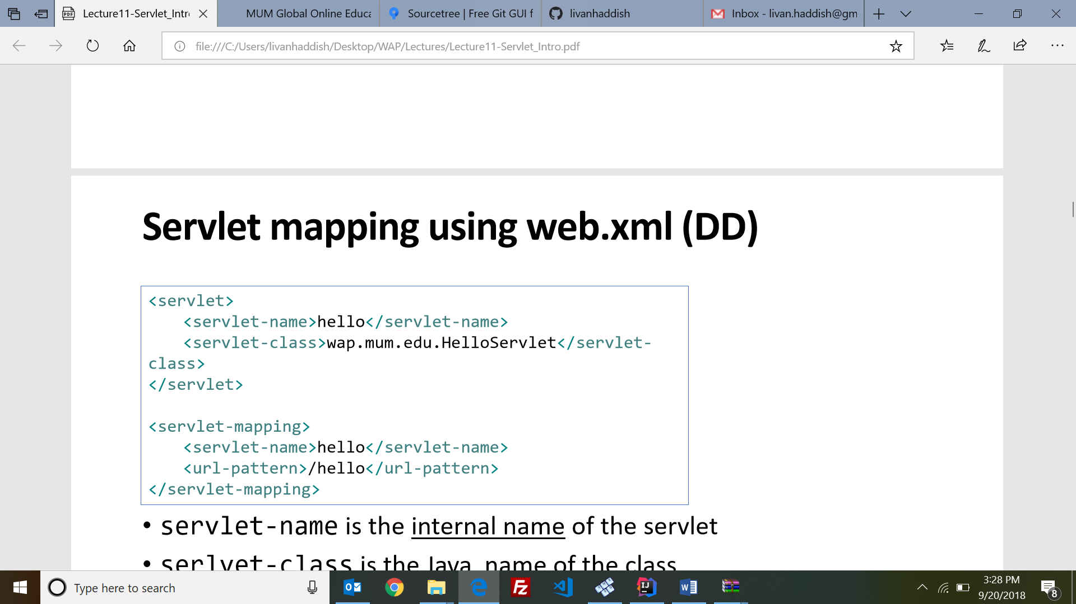

* servlet-name is the internal name of the servlet
* serlvet-class is the Java name of the class
* url-pattern is the way the Servlet is specified in url bar or in the HTML form
* Servlets can be declared and mapped using annotations instead of xml.

E.g : @WebServlet("/hello")

public class HelloServlet extends HttpServlet { ... }

* XML configurations overwrites annotated configurations.

**XML vs Annotations**

**XML**

• Centralized file to change the project

• You need to restart after deploy

• Still need to use XML when annotations don't get the job done.

**Annotations**

• Annotations are in the same file which makes it easy to track and understand the purpose of the file

• Change should be done in all files

• No need to restart after change, the container will compare the servlet file version with the one in memory and update it accordingly.

* XML configurations overwrites annotated configurations.
* **Context Init parameters** Declared using **<context-param>** tag with in the web.xml

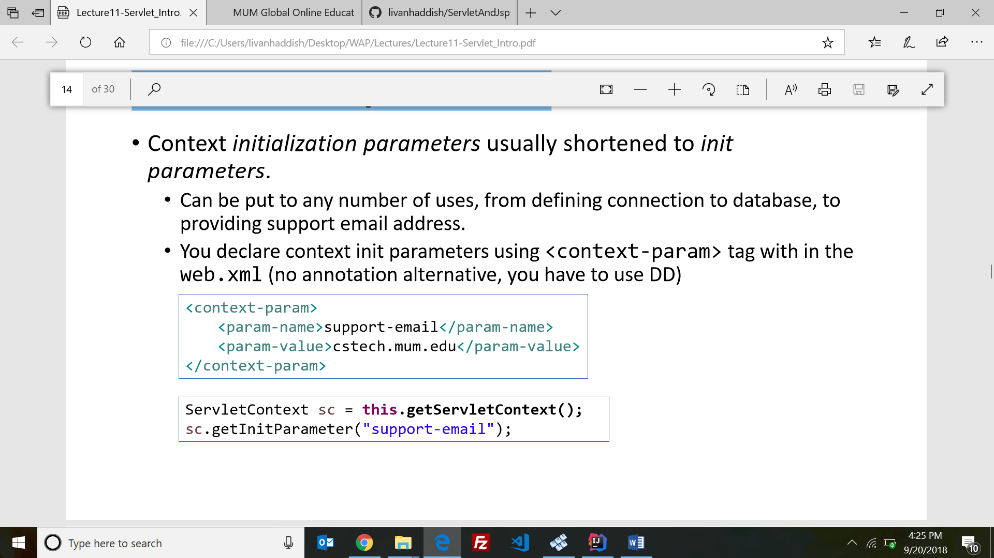

* You can also obtain inti parameter from the ServletConfig object.
* Every platform for web applications has a mechanism to dynamically generate web pages containing information from the server. On the Java platform Servlets are the Java classes that provide this dynamism.
* **Container:**

- Servers that support servlets have as a helper application, a servlet container.

- When a request comes to the web server and is for a servlet, it passes the request data to the servlet container.

- The servlet container locates the servlet, creates request and response objects and passes them to the servlet, and returns to the web server the response stream created. Then the web server sends the response back to the client browser

* **How container handles an HTTP request**

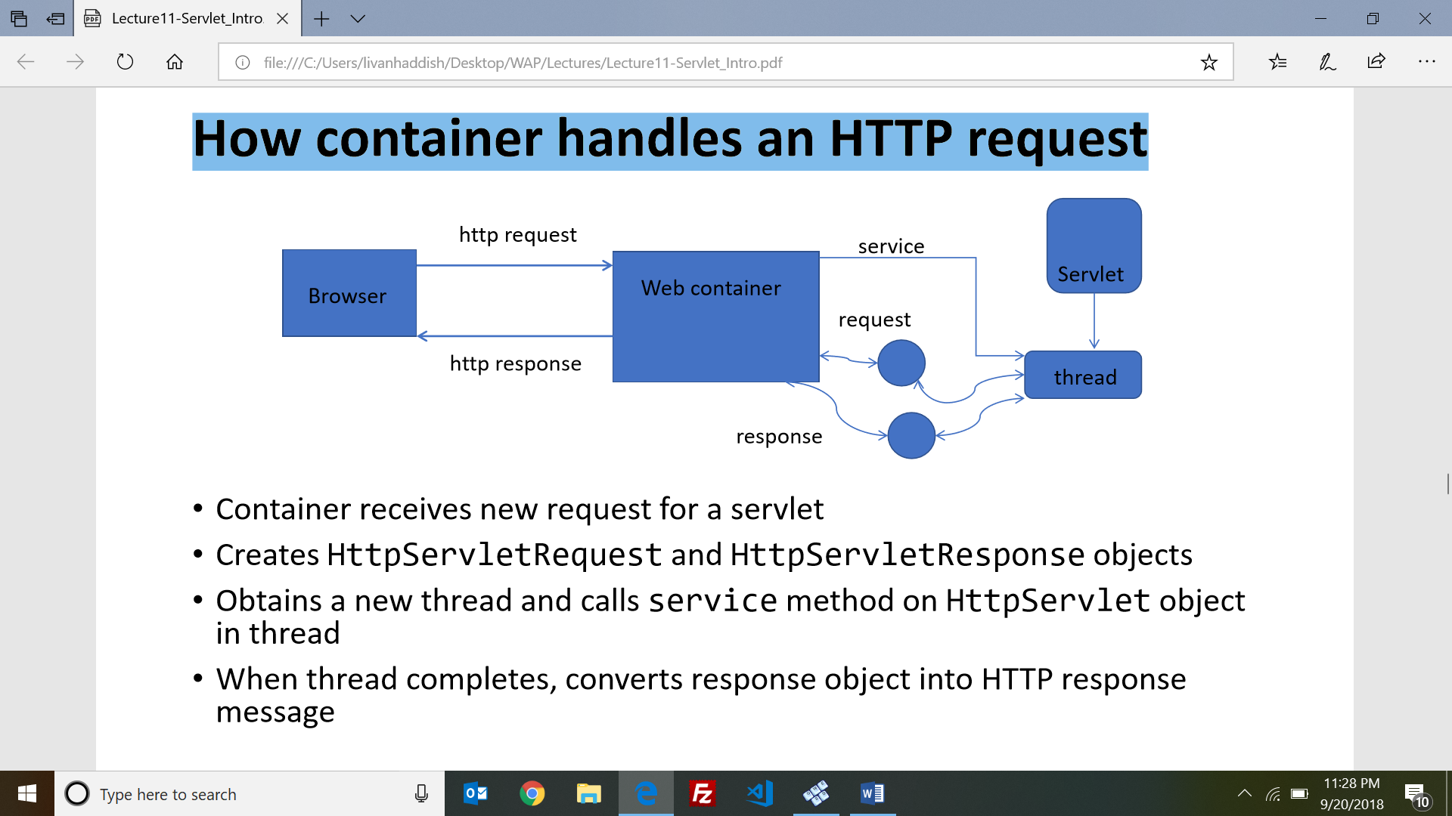

• Container receives new request for a servlet

• Creates HttpServletRequest and HttpServletResponse objects

• Obtains a new thread and calls service method on HttpServlet object in thread

• When thread completes, converts response object into HTTP response message

* Containers provide fundamental support like: network communications, lifecycle management, concurrency, state management, security, Support for JSP.
* **service() method**: The servlet container (Tomcat) calls the service method to handle requests coming from the client (browsers) and to write the formatted response back to the client.
* Each time the server receives a request for a servlet, the server starts a new thread and calls service. Threads share the same instance (and instance variables) of the servlet class.
* **Servlet life cycle**

• Single instance of servlet

• new thread created for every request

• All threads share instance variables

• Each thread has own stack for local variables

* **init** and **destroy methods** do nothing by default, but you can override then to perform some actions.
* E.g.

@Override

public void init() throws ServletException

{ System.out.println("Servlet " + this.getServletName() + " has started."); }

@Override

public void destroy()

{ System.out.println("Servlet " + this.getServletName() + " has stopped."); }

* **init** is called after the Servlet is constructed but before it can respond to the first request. Likewise, **destroy** is called immediately after the Servlet can no longer accept the request.
* the servlet is instantiated and init method is called when the first request arrives for the Servlet after the web application starts.
* 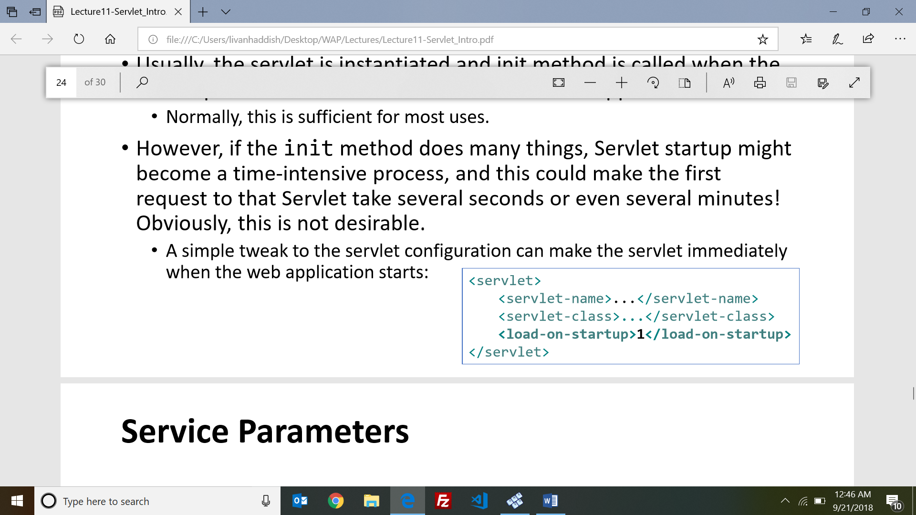A simple tweak to the servlet configuration can make the servlet immediately when the web application starts :
* **Service Parameters**

• HttpServletRequest implements ServletRequest.

• HttpServletResponse implements ServletResponse.

* They are Managed by the container, passed to the servlet.
* **HttpServletRequest**

Using the request, the service method can tell if the http request was a GET or POST and delegate to the appropriate method in the servlet class. It also gets header information, gets Session & Cookie related to the request, gets User information, gets Path and url.

* The Servlet API does not differentiate between two type of parameters.
* The **getParameter** method returns a single value for a parameter. If the parameter has multiple values, it returns the first value
* **getParameterValues** returns an array of values for a parameter.
* **HttpServletResponse:** use the response object to do this such as: set response headers, write to the response body, redirect the request, set the HTTP status code , send cookies back to the client.
* Web applications are, by nature, multithreaded applications which makes it not thread safe.
* It is important to synchronize access to these shared resources to keep their contents from being corrupt and possibly causing errors in your application.

====================================================================================

**LECTURE 12 - Maintaining State**

* HTTP is a stateless protocol. Every request is new request to the server.
* **Why is state necessary?**

• Application often cannot function correctly being totally stateless. E.G online shopping website, Remembering users throughout the session, Enabling Application Workflow (checkout task like filling billing address, credit-card info….).

* **How to maintain state?**

**•** Container managed states: Request scope, Session scope, Application scope

• Cookies

• Hidden form fields

* **What is an attribute?**

Attributes are objects on the server. They promote communication and integration between components.

• It is an object bound into one of the three servlet API objects: HttpServletRequest ,HttpSession,

ServletContext

• Is a name value pair

• Methods (on request, session, or context objects) : getAttribute(String), setAttribute(String,

Object), removeAttribute(String), getAttributeNames()

* Request scope attributes is only available for that request (thread safe). E.g

• request.setAttribute("myAttr", val);

• request.getAttribute("myAttr");

* Session scope attributes is available through the session(not thread safe). E.g

• request.getSession().setAttribute("myAttr", val);

• request.getSession().getAttribute("myAttr");

* Context scope attributes is application level state(its global and its not thread safe). E.g.

• request.getServletContext().setAttribute("myAttr", val);

• request.getServletContext().getAttribute("myAttr");

* **Redirecting requests**

E.g. redirect (to a specified URL)

response.sendRedirect("http://www.cs.mum.edu"); // to external link

response.sendRedirect("result.jsp"); // within same application

* **Forwarding requests**

E.g. forward (to another Servlet or JSP in same application)

RequestDispatcher dispatcher = request.getRequestDispatcher("result.jsp");

dispatcher.forward(request, response);

* **Forward:** passes the request to another resource on the server. Sometimes referred as "server side redirect". URL in browser address bar will remain unchanged
* **Redirect:** server sends HTTP status code 3xx to client along with the redirect URL (usually 302 temporary redirect) , then client then sends a new request to the URL and address bar will change to new URL
* **Post Redirect Get (PRG) pattern:** a web development design pattern that prevents some duplicate form submissions, creating a more intuitive interface for user agents (users).

E.g. refresh button

* When choosing the right scope, use the smallest scope possible.
* Cookies are saved on user's (client) machine as plain text file

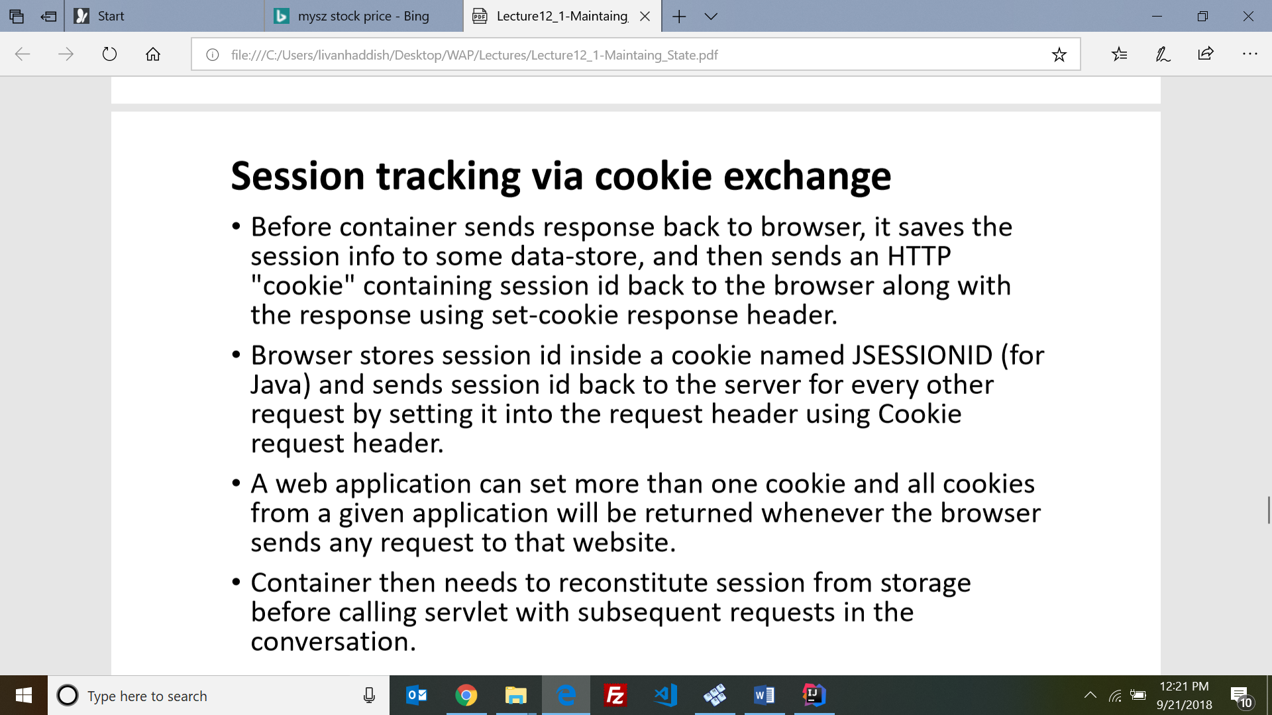

* Another popular method for transmitting session IDs is through URLs.
* **(HTTP) Cookies**

• temporary cookie: this is default. E.g session cookie.

• permanent cookie: a cookie that has a max age set

* **Sending a Cookie :**

Cookie cookie = new Cookie("Name", "Jack");

cookie.setMaxAge(3600); //in seconds

response.addCookie(cookie);

* **Reading a cookie :** Cookies come with the request, can only get all cookies, then search for the one you want.

for (Cookie cookie : request.getCookies()) {

if (cookie.getName().equals("Name")) {

String userName = cookie.getValue(); } }

* To delete a persisting cookie you have to resend cookie with same name after setting its max age value to be negative integer.
* **Obtaining a session**

HttpSession session = request.getSession(); //creates new session if none exists

session.isNew(); //checks whether is a new session

request.getSession(false); //returns null if none exists

* **3 ways for container to remove sessions:**

**session timeout in the DD**

* <session-config> <session-timeout> 30 </session-timeout> </session-config>

**Programmatic ways**

* session.setMaxInactiveInterval(20*60); //seconds
* session.invalidate(); //immediate
* Web applications can use many different types of memory management.State information can be stored in request, session, or context scope, and also as hidden fields or cookies.

=====================================================================================

**LECTURE 12 - Servlet Filters**

* Filters can inspect and modify requests and responses, and they can even reject, redirect, or forward requests.
* The **javax.servlet.Filter** interface is very simple and involves the HttpServletRequest and HttpServletResponse
* **Uses of filters:**

• Logging Filters

• Authentication Filters

• Compression and Encryption Filters

• Error Handling filters

* The **doFilter** method is called when a request comes in that is mapped to the filter. It provides access to the ServletRequest, ServletResponse, and FilterChain objects.
* **Filter Chain**
* Calling **FilterChain.doFilter()** triggers the continuation of the filter chain.
* If the current filter is the last filter in the chain, calling FilterChain.doFilter() returns control to the Servlet container, which passes the request to the Servlet.
* If the current filter does not call FilterChain.doFilter(), the chain is interrupted, and the Servlet and any remaining filters never handle the request.
* Just like Servlets, filters can be mapped to URL patterns. This determines which filter or filters will intercept a request.
* Instead of mapping your filter to a URL or URLs, you can map it to one or more Servlet names.
* **Mapping Filters**
* **Using the Deployment Descriptor**

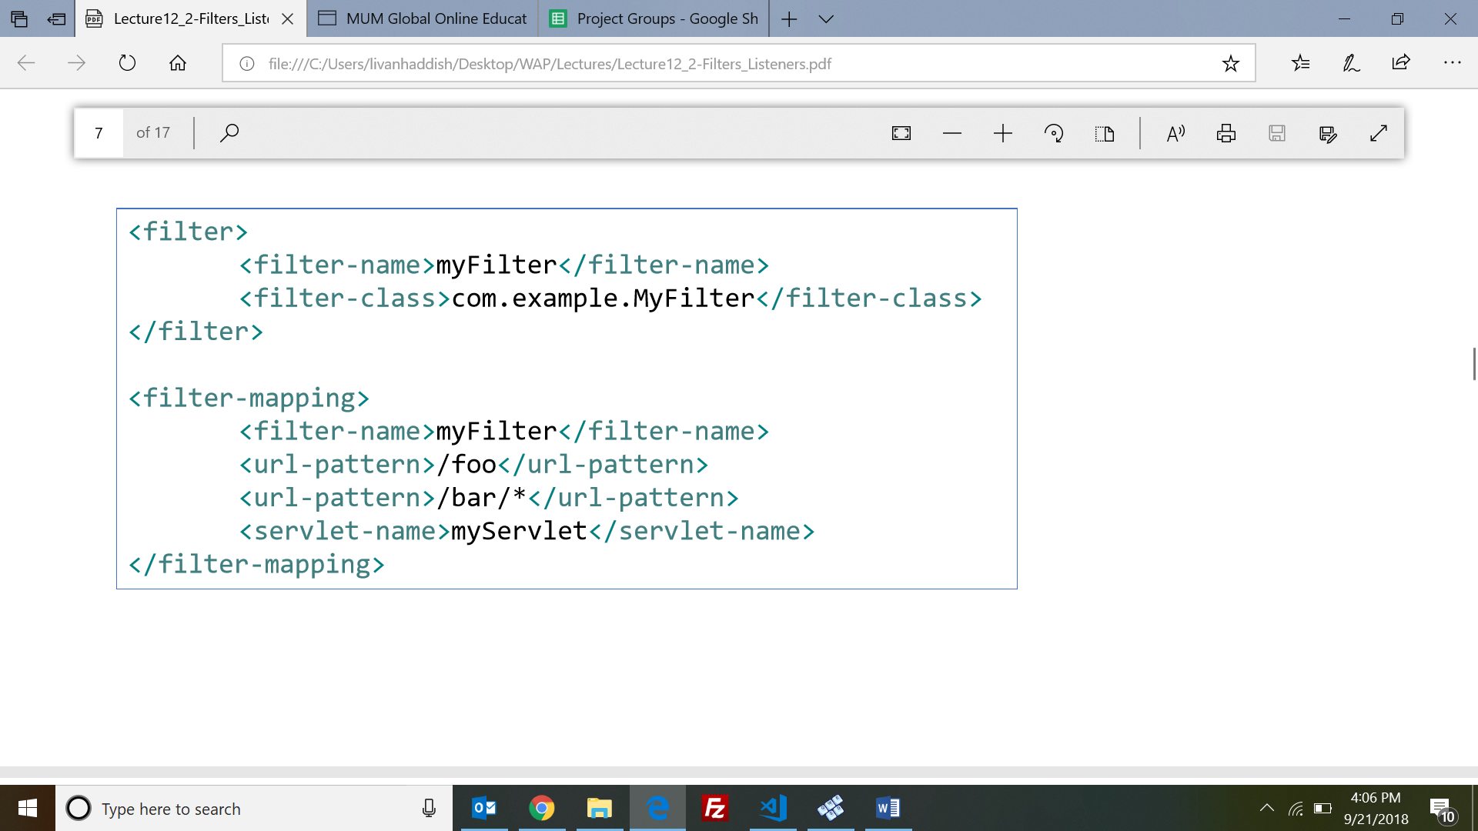

* **Using Annotations**

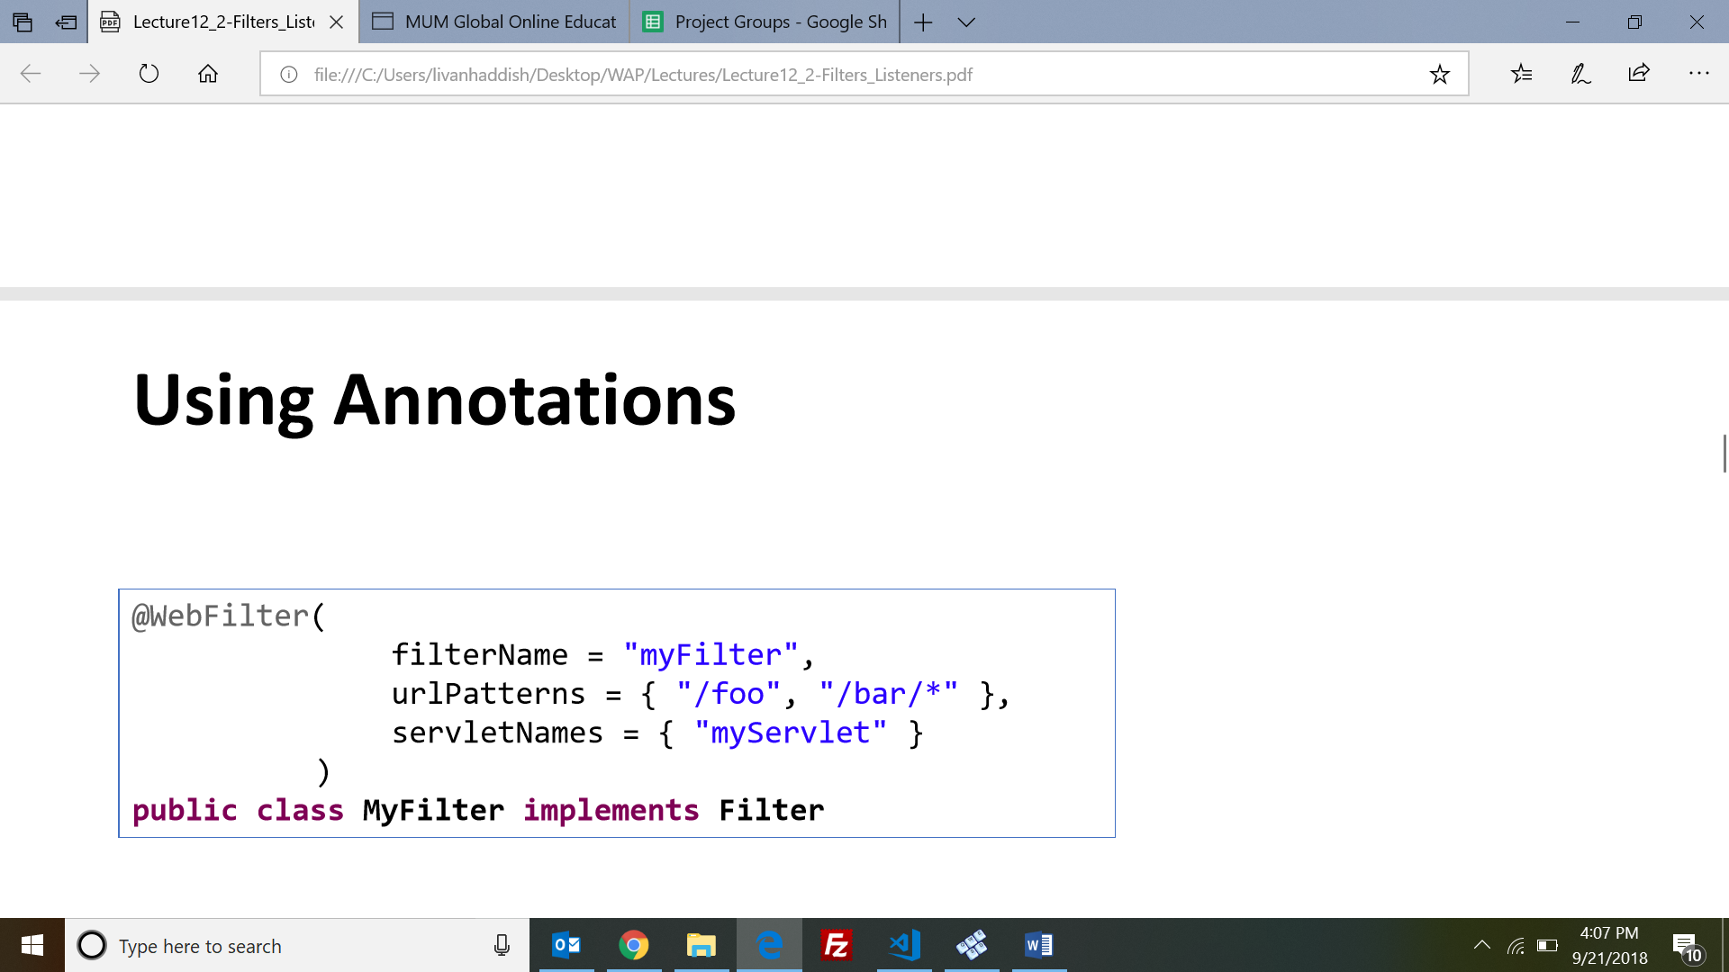

* The **RequestLogFilter** class in demo is the first filter in the filter chain for all requests to the application. It times how long a request takes to process and logs information about every request that comes in to the application

**Events and Listeners**

* **Events** are basically occurrence of stimuli.
* We can bind listener (method) to the subject, for event of our interest and take our actions when specified event fires.
* **Attaching (listing) Listeners**
* @WebListener

public class MyListenerClass implements xxxListener { ... }

<listener> <listener-class>com.example.MyListenerClass</listener-class> </listener>

* **Demo 1 – ServletConextListener**

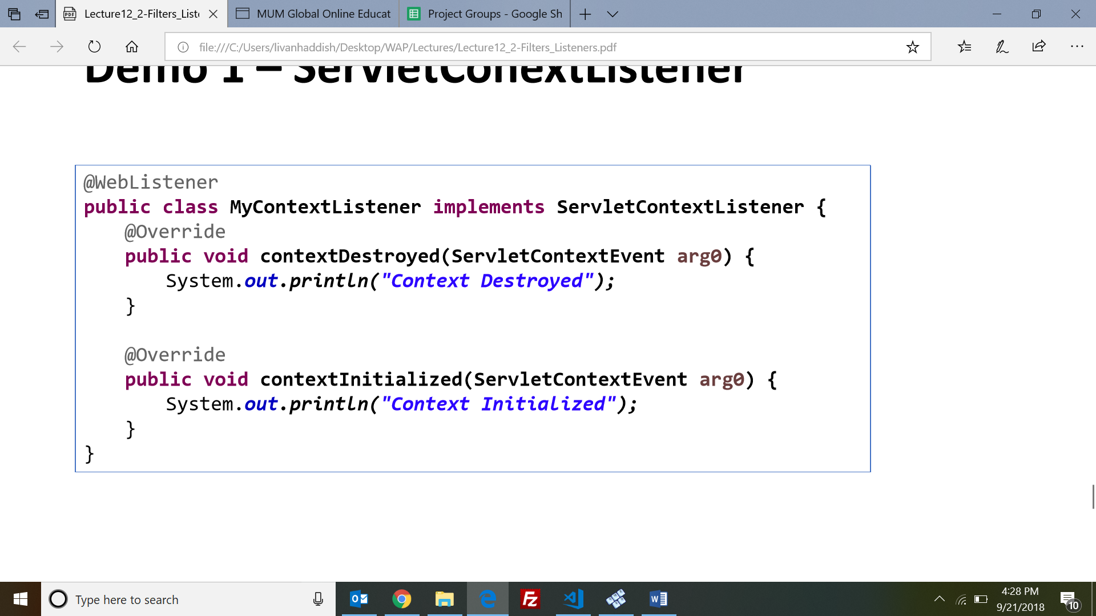

* **Demo 2 – HttpSessionListener**

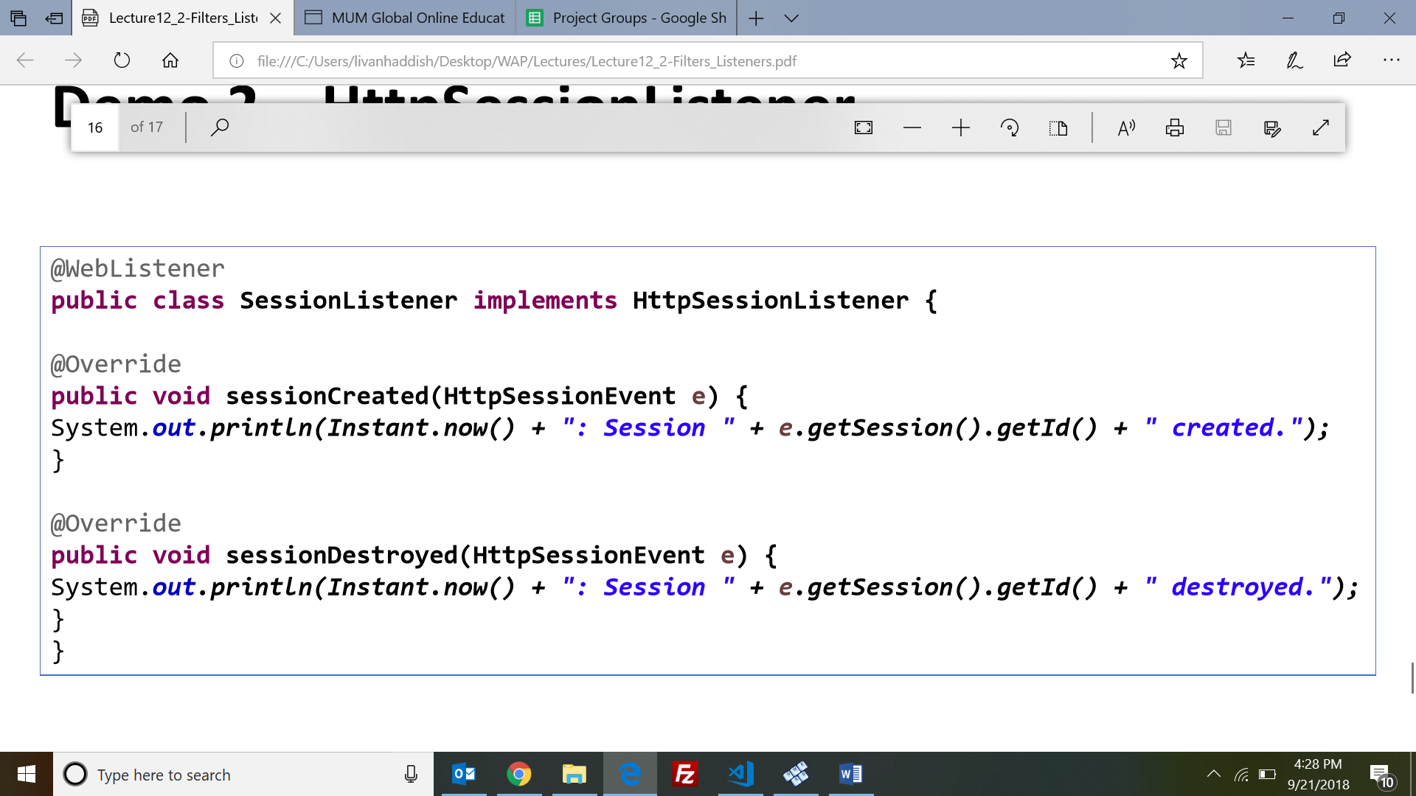

**=====================================================================================**

**LECTURE 13 - Java Server Pages**

* Main idea of JSP is to separate display from processing, i.e., separate html from java
* **Servlet** is java with some html mixed in a little plain java code and lots of enclosed HTML.
* **JSP** is html with a little java mixed in a little java code bracketed in <% …. %> and lots of plain HTML
* Two types of data in a JSP page:

• Template Data: The static part, copied directly to response

• JSP Elements: The dynamic part, translated and executed by the container.

* **Simplest JSP page**

<%@ page contentType="text/html;charset=UTF-8"%>

<!DOCTYPE html> <html> <head> <title>Hello World Application</title> </head> <body>Hello, World!</body> </html>

* Your JSP compiles differently based on web container you run it on.
* **JSP Lifecyle:** Translation, Compilation, Loading, Execution Phase
* **Four types of JSP elements:**

**• Directives:** <%@ directive %>

• **Scriptlets** **:** embedded Java statements: <% scriptlet %> <%= scriptlet expression %>

• **EL Expressions:** more convenient and powerful than a JSP expression**:**  ${ EL Expression }

**• Actions using taglibs**: <c:foreach />

* **JSP scripting elements:**

• **Declaration:**

<%! Inserts instance variable and method declarations into servlet p292 %>

<%! int count = 0; %>

• **Scriptlet:** Inserts Java statements inside service method

<% inserts into the service method %>

<% count = count * 10; %>

• **Expression:** expects a Java expression, which it puts inside 'out.print' in service method

<%= ++count %> becomes … out.print( ++count ); … in service method

• **Comment:**

<%-- jsp comment --%>

* HTML comments get sent to the browser (part of the HTML) , but JSP comments are processed by container and do not appear in generated JSP.
* **JSP Directives:** message from a JSP page to the JSP container that controls processing of entire page.
* In a well-structured, cleanly coded application, the presentation layer is separated from the business logic, which is likewise separated from the data persistence layer.
* It is preferred to create JSPs that display dynamic content without single line of Java inside the JSP , so people don’t change our codes unintentionally.

**Forwarding a Request from a Servlet to a JSP**

* A typical pattern when combining Servlets and JSPs is to have the Servlet accept the request, do any business logic processing and data storage or retrieval necessary, prepare a model that can easily be used in JSP, and then forward request to the JSP.

request.getRequestDispatcher("/WEB-INF/jsp/welcome.jsp") .forward(request, response);

* The web container generates a servlet from a JSP file the first time the JSP is requested from a web application.
* **Expression Language (EL)** was originally developed as part of the JSP Java Standard Tag Library (JSTL), to support the rendering of data on JSP pages without the use of scriptlets, declarations, or expressions.
* Use of EL makes codes familiar to both Java developers and UI developers, and with a simple set of rules and operators to make data access and manipulation easier.

E.g. JSP "expression" : <%= ((User) request.getAttribute("user")).getDog().getName() %>

EL simplifies JSP expression syntax: ${user.dog.name}

* Unlike Java, where string literals are always surrounded by double quotes, string literals in EL can be surrounded by either double or single quotes, similar to JavaScript.
* Implicit variables in EL : pageScope, requestScope, sessionScope, applicationScope….etc
* the implicit scope is more useful and more commonly used because of its capability to resolve an attribute in the page, request, session, or application scope.
* When an EL expression references a variable, the EL evaluator resolves the variable using the following procedure:

• It checks if the variable is one of the 11 implicit variables.

• If the variable is not one of the 11 implicit variables, the EL evaluator next looks for attribute starting with the page scope until application scope, if not found it ignores the expression.

* E.g: ${something}

It checks if the variable is one of the 11 implicit variables with an attribute named "something", if found use it; otherwise checks page scope, request scope, session scope, application scope otherwise ignore the expression

* **More detailed description**

${firstThing[secondThing]}

• if firstThing is a bean then secondThing is a property of the bean

• if firstThing is a map then secondThing is a key of the map

• if firstThing is a List then secondThing is an index into the List

* You cannot access fields using EL expressions, even if they are public.
* Considering a is object of class A, when the EL engine sees ${a.b} syntax, it is looking for a property b of object a, not a field.
* **Example of EL Bracket notation**

• in Servlet:

String[] fruit= ["Banana", "Orange", "Apple"];

request.setAttribute("myFruitList", fruit);

• in JSP:

${myFruitList[0]} // Banana

${myFruitList["1"]} // Orange

${myFruitList.1} // won't work

* If the thing inside the [] is String literal, it can be a Map or bean or index in a list or array.
* EL is "null friendly".
* If EL cannot find a value for the attribute it ignores and gives no warning or error message
* **An EL expression** is a compact expression of a systematic evaluation of the page, request, session and application scopes.
* **JSP Model 1 and Model 2 Architectures**

When you use JSP pages according to a Model 2 architecture, there is a servlet that acts as a controller that sets attribute values based on computations and results from a business model, then dispatches the request to the servlet generated by the **JSP page .** The JSP servlet then retrieves the attribute values and inserts them into the designated places in the HTML being sent to the browser.

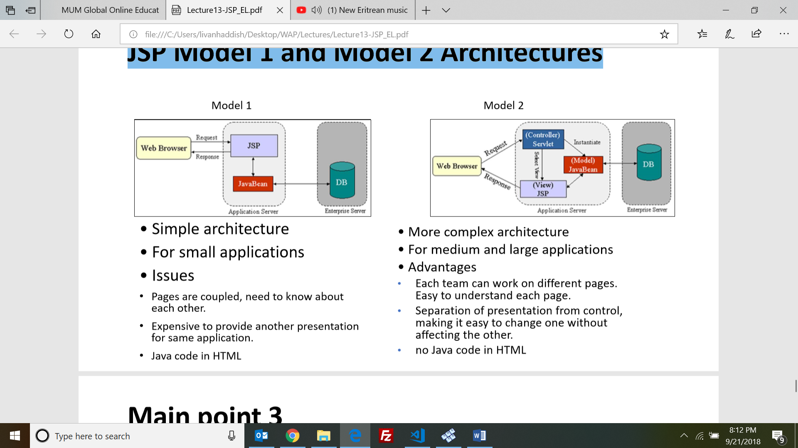

**==============================================================================**

**((READ FROM SLIDE, A LOT OF SYNTAXING))**

**LECTURE 14 - JSP – Standard Tag Library**

* The Java Server Pages Standard Tag Library **(JSTL)** is a collection of useful JSP tags which encapsulates core functionality common to many JSP use cases.
* There are five tag libraries in the Java Standard Tag Library specification: • Core (c) • Formatting (fmt) • Functions (fn) • SQL (sql) • XML (x)

**Using the core tag library**

* The Core tag library, contains nearly all the core functionality you need to replace the Java code in your JSPs.
* Before you can use core tag library, you first include it to your page and give the appropriate prefix (c) which you will use later on your JSP code to refer this library.

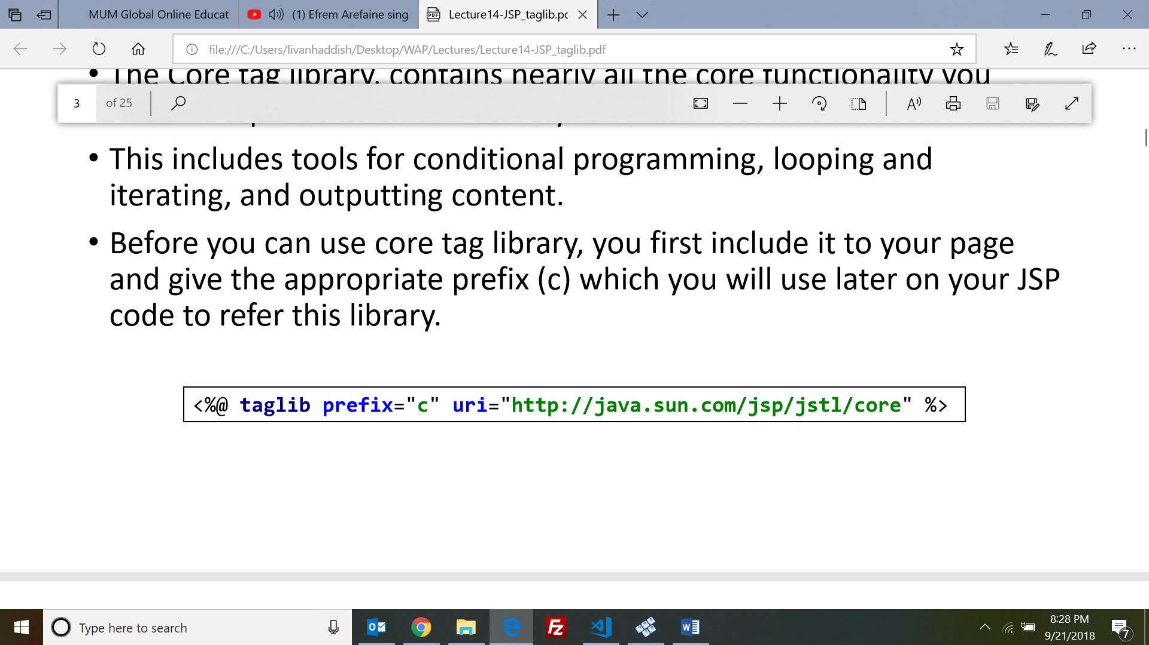

* Tags in the Core library:
* **<c:out> :** Outputting content to your JSPs.
* **<c:url> :** thistag properly encodes URLs, and rewrites them if necessary to add the session ID, and can also output URLs in your JSP.
* **<c:if>**
* **<c:choose>, <c:when>, and <c:otherwise>**

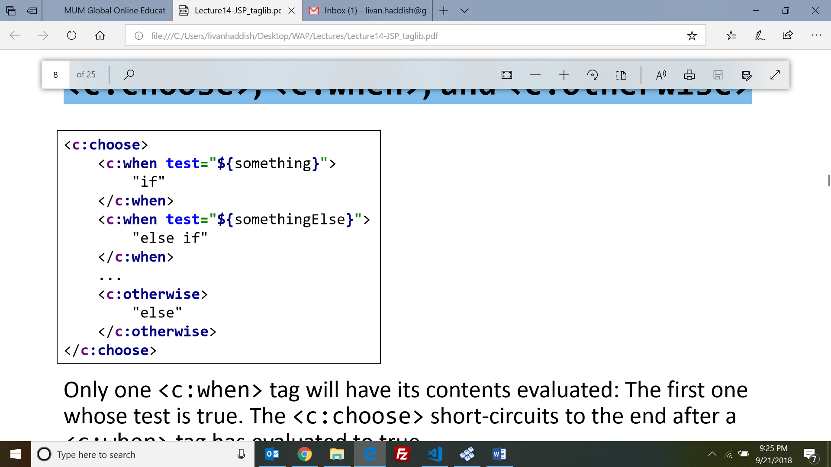

* **<c:forEach>**

<c:forEach var="i" begin="0" end="100">

Line ${i}<br />

</c:forEach>

* **<c:forEach>**
* **<c:redirect> :** redirects the user to another URL.
* All JSP tags result in execution of some tag handler.
* A tag handler is specified within a tag definition in a TLD, and the container uses this information to map a tag in a JSP to the Java code that should execute in place of that tag.

**Custom Tags**

* **A custom tag** is a user-defined JSP language element. When a JSP page containing a custom tag is translated into a servlet, the tag is converted to operations on an object called a tag handler.
* To write a custom tag you can simply extend SimpleTagSupport class and override the doTag()method, where you can place your code to generate content for the tag
* **Why JSP custom tags are important**

purpose of most JSP custom tags is to provide an easy mechanism to dynamically "generate markup" for common processing tasks

**==================================================================**